Mathematics Standard 2 Year 12
Algebra Topic Guidance

Mathematics Standard 2 Year 12 Algebra Topic Guidance
Topic focus 3
Terminology 3
Use of technology 3
Background information 3
General comments 4
Future study 4
Subtopics 4
MS-A4: Types of Relationships 5
Subtopic focus 5
A4.1 Simultaneous linear equations 5
Considerations and teaching strategies 5
Suggested applications and exemplar questions 5
A4.2 Non-linear relationships 6
Considerations and teaching strategies 6
Suggested applications and exemplar questions 6

Topic focus
Algebra involves the use of symbols to represent numbers or quantities and to express relationships. It is an essential tool in problem-solving through the solution of equations, graphing of relationships and modelling with functions.
Knowledge of algebra enables the modelling of a problem conceptually so that it is simpler to solve, before returning the solution to its more complex practical form.
The study of algebra is important in developing students’ reasoning skills and logical thought processes, as well as their ability to represent and solve problems.

Terminology
asymptote   axis of symmetry  braking distance  break-even point   constant  cost  exponential function  exponential model  graph  growth or decay | hyperbola  intercepts  inverse variation  linear  linear equations  model  non-linear  parabola  point of intersection  quadratic function | quadratic model  reciprocal function  reciprocal model  rectangular hyperbola  revenue  simultaneous linear equations  sketch  straight-line graph  turning point  variation

Use of technology
Students can use a spreadsheet to generate a table of values and the associated linear graph to find the points of intersection of graphs, for example in break-even analysis.
Suitable graphing software can be used to create graphs of functions and when investigating the similarities and differences between the graphs of a variety of linear and non-linear relationships.
Students should have access to appropriate technology in order to create graphs of functions, including linear, quadratic, hyperbolic and exponential functions.

Background information
Over 4000 years ago, the Babylonians solved simple systems of linear equations with two unknowns. The first recorded example of the solution of simultaneous linear equations by elimination was in the ancient Chinese work Jiuzhang suanshu (Nine Chapters of the Mathematical Art, circa 100 BCE–50 CE). However, it was not until the late 17th century that the modern study of linear algebra originated through the work of Gottfried Leibnitz (1646–1716).

Non-linear relationships appear frequently in the areas of science and economics and are fundamental to many physical phenomena. For example, the motion of thrown objects, models of population growth, the value of a car and the length of time it has been owned or the amount of time it takes to complete a task and the number of people doing it.
Graphs can often be used to solve problems that would be difficult to solve by other means.

General comments
Algebraic skills can be developed through the use of formulae and algebraic expressions from vocational and other practical contexts.
Students may require review of Stage 5 or Year 11 material at the start of this topic to ensure they have appropriate knowledge, understanding and skills of algebraic manipulation.

Future study
Linear algebra is useful in solving network problems, such as analysing traffic flow patterns. It is also the basis of linear programming, a process widely used in business to solve problems involving multiple numbers of variables.
The concept of variation is widely used in many applications of algebra in further studies and in the workplace.
Students who undertake future studies in science and business will benefit from a deeper understanding of the interpretation and use of algebra to solve real-life problems.

Subtopics
- MS-A4: Types of Relationships

MS-A4: Types of Relationships

Subtopic focus
The principal focus of this subtopic is the graphing and interpretation of relationships, and the use of simultaneous linear equations in solving practical problems.
Students develop their ability to communicate concisely, use equations to describe and solve practical problems, and use algebraic or graphical representations of relationships to predict future outcomes.
Within this subtopic, schools have the opportunity to identify areas of Stage 5 content which may need to be reviewed to meet the needs of students.

A4.1 Simultaneous linear equations

Considerations and teaching strategies
- Students should be able to recognise the limitations of linear models in practical contexts, for example a person’s height as a function of age may be approximated by a straight line for a limited number of years. Students should be aware that models may apply only over a particular domain.
- Students use graphing software to construct graphs of simultaneous linear equations to solve problems involving the identification of ‘break-even’ points, for example graphs of costs and income or finding the time period following installation for an appliance to start to save money for a household.
- Students should be able to solve ‘break-even problems’ graphically in questions which emphasise the break-even point, the profit zone and the loss zone, and interpretation of the $y$-intercept.

Suggested applications and exemplar questions
- In break-even analysis, students learn that the profit or loss can be calculated using the formula: $profit (loss) = income – costs$. They should be able to recognise and interpret the income equation and cost equation drawn on the same graph.
- The income function is a simple linear function of the form $I=mx$, where $x$ is the number of units sold and $m$ is the selling price per unit sold. The cost function is of the form $C=mx+c$, where$x$ is the number of units sold, $m$ is the cost price per unit manufactured, and $c$is the fixed costs of production. The point of intersection of $I$ and $C$ is the ‘break-even point’.
For example, consider the following scenario: A cake-shop owner sells muffins for $2.50 each. It costs $1 to make each muffin and $300 for the equipment needed to make the muffins.
In this example the income function is $I=2.5x$ and the cost function is $C=1.25x+300.$ These are illustrated in the following graph.

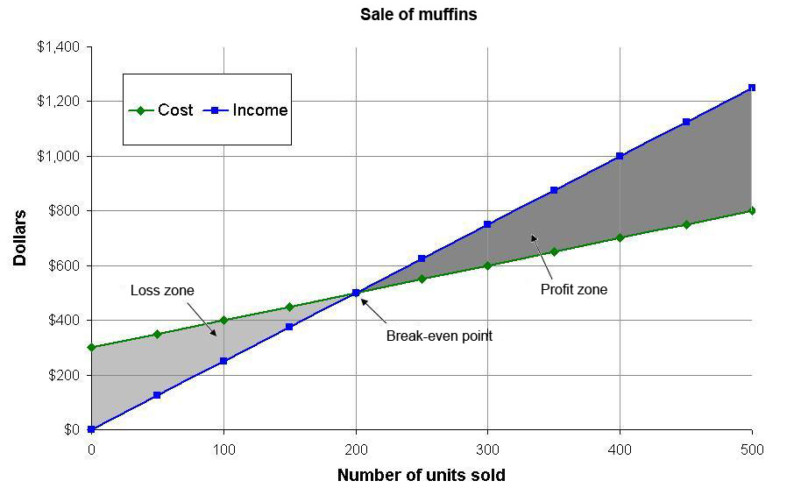
The break-even point is the solution of the equation $I=C$, which can be solved graphically or algebraically.

A4.2 Non-linear relationships

Considerations and teaching strategies
- Graphing software should be used to investigate various quadratic functions and their maximum and minimum values.
- Graphing software can be used to vary coefficients and constants of the various functions addressed in this topic to observe changes to the graphs of the functions.
- Students should explore the effect of changing the values of $a, k$ and $c$ on the graph of the functions $y=ka^{x}+c$ and $y=\frac{k}{x}+c$.
- The concept of an asymptote should be explored with reference to hyperbolas and exponential functions. For example,
  - $y=5$ is the asymptote of $y=2^{x}+5$ and
  - both $x=0$ and $y=0$ are asymptotes of $y=\frac{4}{x}$
- Variation problems should be presented in a number of formats, including in written, tabular and graphical form.
- In modelling physical phenomena, functions and graphs should involve only positive values of the independent variable and zero.

Suggested applications and exemplar questions
- Investigate models of population growth, for example the population growth of bacteria.
- An exponential expression such as $M=1.5{\left(1.2\right)}^{x}$ can be used to calculate the mass $M$ kg of a baby orangutan at age $x$ months. This model applies for a limited time, up to $x=6$. Calculate the mass of a baby orangutan at age three months.
- Investigate compound interest as the time period shortens.
- Sketch at least 10 rectangles that have the same perimeter. Record length versus area in a table. Sketch the resulting function and use the graph to determine the rectangle with maximum area. Describe this rectangle.
- On the Earth, the equation $d=4.9t^{2}$ can be used to express the distance ($d$metres) that an object falls in $t$ seconds, if air resistance is ignored. Investigate the equations for the moon and for other planets: for example on the moon, the equation is
$d=0.8t^{2}$. Create a table of values for the function $d=4.9t^{2}$ either manually or by using a spreadsheet, and use the table to answer questions such as: How long does it take for an object to fall 300 m?
- Inverse variation can be used to find how much each person contributes when a cost is shared. For example, a household has $306 in bills. Create a table and draw a graph to show how much each person pays if there are 2, 3, 4 or 5 people contributing equally to pay the bills.
- Anjali is investigating stopping distances for a car travelling at different speeds. To model this she uses the equation $d=0.01s^{2} + 0.7s$, where $d$is the stopping distance in metres and $s$ is the car’s speed in km/h. The graph of this equation is drawn below.
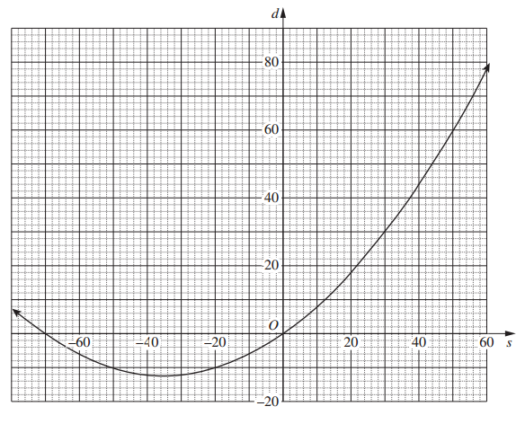
- Anjali knows that only part of this curve applies to her model for stopping distances. In your writing booklet, using a set of axes, sketch the part of this curve that applies for stopping distances.
- What is the difference between the stopping distances in a school zone when travelling at a speed of $40$ km/h and when travelling at a speed of $70$ km/h?
- In 2010, the city of Thagoras modelled the predicted population of the city using the equation $P=A{(1.04)}^{n}$. That year, the city introduced a policy to slow its population growth. The new predicted population was modelled using the equation $P=A{(b)}^{n}$. In both equations, $P$ is the predicted population and $n$ is the number of years after 2010. The graph shows the two predicted populations.
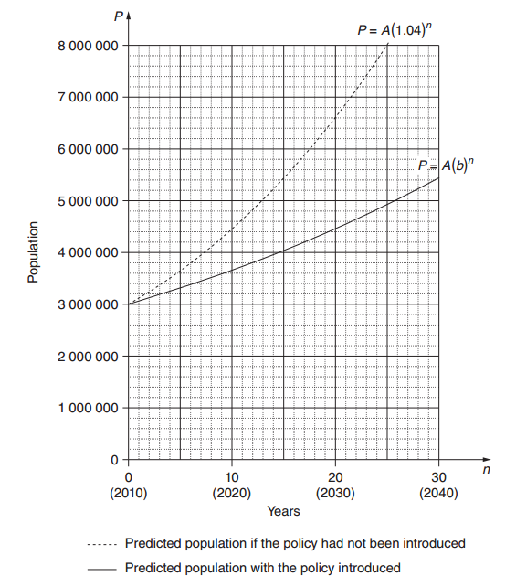
- Use the graph to find the predicted population of Thagoras in 2030 if the population policy had NOT been introduced.
- In each of the two equations given, the value of $A$is $3 000 000$. What does $A$ represent?
- The guess-and-check method is to be used to find the value of $b$, in $P=A{(b)}^{n}$.
- Explain, with or without calculations, why $1.05$ is not a suitable first estimate for $b$.
- With $n=20$ and $P=4 460 000$, use the guess-and-check method and the equation $P=A{(b)}^{n}$ to estimate the value of $b$ to two decimal places. Show at least TWO estimate values for $b$, including calculations and conclusions.
- The city of Thagoras was aiming to have a population under $7 000 000$ in 2050. Does the model indicate that the city will achieve this aim? Justify your answer with suitable calculations.

