Mathematics Standard 1 Year 12
Algebra Topic Guidance

Mathematics Standard 1 Year 12 Algebra Topic Guidance
Topic focus 3
Terminology 3
Use of technology 3
Background information 3
General comments 4
Future study 4
Subtopics 4
MS-A3: Types of Relationships 4
Subtopic focus 4
A3.1 Simultaneous linear equations 4
Considerations and teaching strategies 4
Suggested applications and exemplar questions 4
A3.2 Graphs of practical situations 5
Considerations and teaching strategies 5
Suggested applications and exemplar questions 6

Topic focus
Algebra involves the use of symbols to represent numbers or quantities and to express relationships. It is an essential tool in problem-solving through the solution of equations, graphing of relationships and modelling with functions.
Knowledge of algebra enables the modelling of a problem conceptually so that it is simpler to solve, before returning the solution to its more complex practical form.
Study of algebra is important in developing students’ reasoning skills and logical thought processes, as well as their ability to represent and solve problems.

Terminology
break-even point   cost  equation  exponential  exponential model  graph | linear  linear equations  model  non-linear  non-linear model  physical phenomena | point of intersection  profit  revenue  simultaneous linear equations  sketch  straight-line graph

Use of technology
Suitable graphing software can be used to create graphs of functions and to investigate the similarities and differences between the graphs of a variety of linear relationships.
Students can use a spreadsheet to generate a table of values and the associated graph and to find the points of intersection of graphs, for example in break-even analysis.
Students can explore graphs of physical phenomena that are available on the internet. For example: https://teacher.desmos.com/waterline/walkthrough#Tumbler.

Background information
Over 4000 years ago, the Babylonians solved simple systems of linear equations with two unknowns. The first recorded example of the solution of simultaneous linear equations by elimination was in the ancient Chinese work Jiuzhang suanshu (Nine Chapters of the Mathematical Art, circa 100 BCE–50 CE). However, it was not until the late 17th century that the modern study of linear algebra originated through the work of Gottfried Leibnitz (1646–1716).
Exponential relationships arise frequently in the areas of science and economics and are fundamental to many physical phenomena. For example, the growth of a population or the value of a car and the length of time it has been owned are both exponential relationships.
Graphs can often be used to solve problems that would be difficult to solve by other means.

General comments
Algebraic skills should be developed through the use of formulae and algebraic expressions from a range of practical contexts.
Students may require review of Stage 5 or Year 11 material at the start of this topic to ensure they have appropriate knowledge, understanding and skills of algebraic manipulation.

Future study
The ability to interpret and critically evaluate information that is presented in graphical form will provide students with important skills they will use as when making decisions in the future.

Subtopics
- MS-A3: Types of Relationships

MS-A3: Types of Relationships

Subtopic focus
The principal focus of this subtopic is the graphing and interpretation of relationships, and the use of simultaneous linear equations in solving practical problems.
Students develop their ability to communicate concisely, use equations to describe and solve practical problems, and use algebraic or graphical representations of relationships to predict future outcomes.
Within this subtopic, schools have the opportunity to identify areas of Stage 5 content which may need to be reviewed to meet the needs of students.

A3.1 Simultaneous linear equations

Considerations and teaching strategies
- Students should be able to solve ‘break-even problems’ graphically in questions emphasising the break-even point, the profit zone and the loss zone, and interpretation of the $y$-intercept.
- Graphing software can be used to generate graphs of linear functions.

Suggested applications and exemplar questions
- This topic lends itself well to using linear models to solve problems or to aid decision- making. Applications include choosing an energy-efficient appliance or car; distance/time problems; mixing proportions of ingredients to make a blend; organising an event; setting ticket prices; problems of supply and demand.
- The following scenario is depicted in the graph below:
A cake-shop owner sells muffins for $2.50 each.
It costs $1 to make each muffin and $300 for the equipment needed to make the muffins.
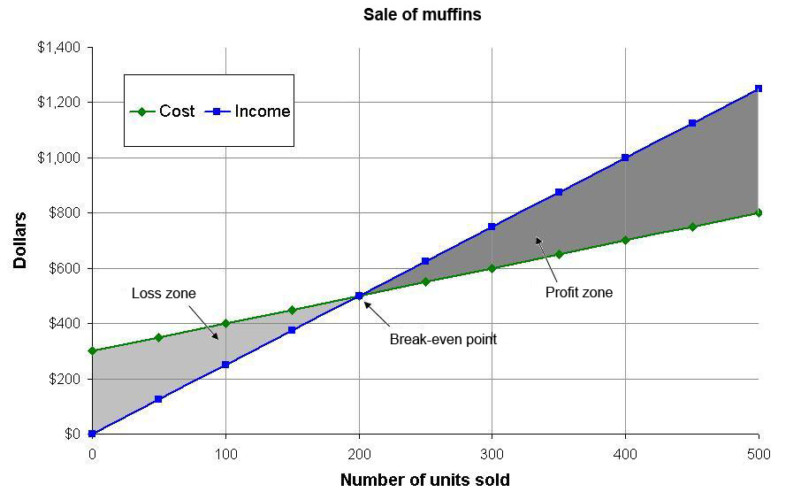
- Typical questions based on the graph could include:
- How many muffins need to be sold to ‘break even’?
- How much profit is made if 400 muffins are sold?
- The graph shows the supply (S) and consumer demand (D) curves for a farm product.
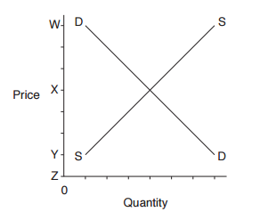
Which letter corresponds to the price at which both the producer and consumer would be satisfied (equilibrium market price)?
(A) W (B) X (C) Y (D) Z

A3.2 Graphs of practical situations

Considerations and teaching strategies
- In modelling physical phenomena, functions and graphs should involve only positive values of the independent variable and zero.
- Students should recognise the limitations of linear models in practical contexts, for example a person’s height as a function of age may be approximated by a straight line for a limited number of years. Students should be aware that models may apply only over a particular domain.
- Students distinguish between linear and non-linear relationships and recognise relationships that can be described as exponential from the shape of the graph.
- Mathematics Standard 1 students are not expected to find the algebraic equation of an exponential function from the graph of the function.
- Students use graphing software to graph exponential functions or develop a table of values and plot the associated points to produce a sketch of the graph.

Suggested applications and exemplar questions
- Students draw and interpret a variety of distance/time graphs.
- Digital technology should be used to construct graphical representations of algebraic expressions.
- Investigate models of population growth.
- Sketch a function showing the growth of a population of bacteria.
- The average height, $C$, in centimetres, of a girl between the ages of $6$ years and$11$ years can be represented by a line with equation $C=6A+79$ where $A$ is the age in years.
- For this line, the gradient is $6$. What does this indicate about the heights of girls aged $6$ to $11$?
- Give ONE reason why this equation is not suitable for predicting heights of girls older than $12$.
- The time for a car to travel a certain distance varies inversely with its speed. Which of the following graphs shows this relationship?
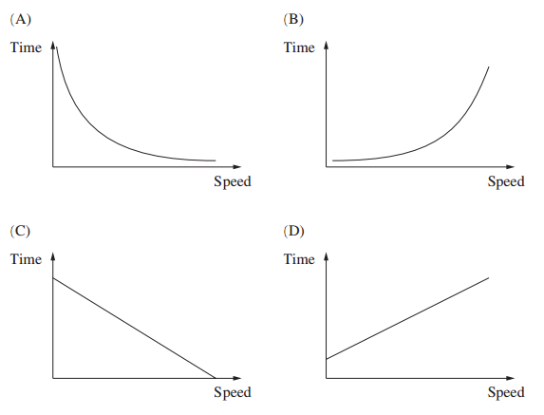
- Water was poured into a container at a constant rate. The graph shows the height of the water level as time passed.
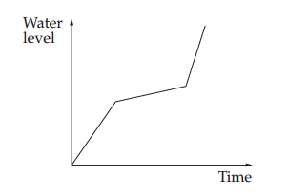
Into which container was the water poured?
