Sample Unit – Mathematics Standard 1 – Year 12
Sample for implementation for Year 12 from Term 4, 2018
Unit title | Introducing Networks |  | Duration | 10 hours
Strand | Networks | Topic | MS-N1: Networks and Paths
Subtopic focus  The principal focus of this subtopic is to identify and use network terminology and to solve problems involving networks.  Students develop their awareness of the applicability of networks throughout their lives, for example social media networks and their ability to use associated techniques to optimise practical problems. |  | Resources  Access to the internet for teacher (and students if possible)  String, ruler, scissors and key rings  Mini whiteboards  Paper for making posters  A variety of appropriate maps and house plans.

Outcomes | Assessment Strategies
A student:  - applies network techniques to solve network problems  MS1-12-8  - chooses and uses appropriate technology effectively and recognises appropriate times for such use MS1-12-9  - uses mathematical argument and reasoning to evaluate conclusions, communicating a position clearly to others  MS1-12-10 | Informal Assessment:  At the start of the unit the teacher assesses students’ prior learning using a variety of different strategies, including:  - students working in small groups to brainstorm what they have heard about networks  - a mind map of where they have heard the word ‘network’ used (social, trains, etc.)  During the unit the teacher may assess student progress using strategies including:  - observing student engagement during in-class problem-solving tasks  - monitoring the completion of homework tasks  - collecting samples of student work to informally assess individual progress  - providing opportunities for students to contribute to class discussion and/or group work  - posing key questions when working in one-to-one situations with students  - starting each lesson with a brief (5 min) quiz that reviews the key concepts of previous lessons and key skills that will be required in the lesson that will follow.  Formal Assessment:  An investigative task in which practical situations such as a cable connection for a computer service or a truck delivery are modelled using networks and analysed.

Content | Teaching, learning and assessment strategies
N1.1: Networks  Students:  - identify and use network terminology, including vertices, edges, paths, the degree of a vertex, directed networks and weighted edges | The teacher introduces students to the Königsberg bridge problem, and students spend some time trying to find a solution: http://nrich.maths.org/1869/index  The teacher explains that in order to make the problem easier to understand, it can be drawn as a network diagram. On the Königsberg bridge problem diagram, the teacher explains that the dots are called ‘vertices’ (or vertex, singular) and the lines are called ‘edges’.  The teacher explains that a ‘loop’ is an edge that connects just a single vertex to itself:  and that there may be multiple edges (also called parallel edges) between vertices: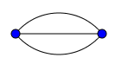.  Vertices connected by an edge can be called ‘adjacent vertices’.  The teacher introduces other problems where students play with a network diagram, and decide if it is ‘traversable’ (can be drawn without taking a pen off the paper or repeating an already drawn edge): http://nrich.maths.org/2326. The students work on the problems.  The students are encouraged to consider why some networks might be traversable and others not. The teacher encourages them to assess how many edges protrude from each vertex and how this might affect the diagram. The teacher defines this number as the degree of the vertex.  The teacher discusses with the class different ways of moving around a network diagram. Students make notes in the form of a glossary (possibly a poster if they wish), for example:  - A path (or chain) joins a starting vertex by a continuous series of edges to a finishing vertex. For a directed network the edges must be in the same direction. Travel can occur along a path.  - A circuit (or cycle) is a path that returns to its starting vertex.  - A simple chain, path, cycle or circuit does not cross over itself, so does not repeat any vertices.  The teacher distributes large sheets of paper with networks drawn on them, and students use different coloured pens to draw a path on the network, or a circuit (simple or otherwise). These are then shared with the class.  The teacher discusses with the class the different types of networks. Students make notes in the form of a glossary (possibly a poster if they wish). Include:  - a connected network, where it is possible to reach every vertex from every other vertex via a path  - a disconnected network, where the network is not connected  - an infinite network, where there are infinitely many vertices and edges  - a directed network, in which each edge has direction  - an undirected network, in which no edges have direction  - a weighted network, in which edges or vertices have a value assigned to them.  The teacher draws different types of networks and places these drawings around the room. Students identify them by moving them to the board and placing them under the correct heading. In some cases they may belong under more than one heading and a useful discussion can ensue.  Students watch the Graph Theory Basics video for consolidation: https://www.youtube.com/watch?v=2RdnHdbgvNg  Students consolidate their work using resources, or the following worksheet:  http://www.suffolkmaths.co.uk/pages/Maths%20Projects/Projects/Topology%20and%20Graph%20Theory/Traversable%20Worksheet.pdf
- solve problems involving network diagrams AAM  - recognise circumstances in which networks could be used, eg the cost of connecting various locations on a university campus with computer cables  - given a map, draw a network to represent the map, eg travel times for the stages of a planned journey  - draw a network diagram to represent information given in a table | Students watch the Graph Theory Basics 2 video to introduce the different ways networks can be represented: https://www.youtube.com/watch?v=CEABLU7QzrY  Students in the room are encouraged to shake hands with each other, and then to represent that as a network diagram and count the number of handshakes that have taken place.  Students use a map, such as the one on this page: http://web2.airmail.net/danb1/mileage.htm that shows distances and routes between cities, to draw a weighted network that represents the map. The teacher may also wish to construct a map of an area familiar to the students. Students should work with the distances given, and calculate average speeds and redraw the same network, but with the weights representing travel times instead.  Students draw the following house plan as a network showing the room connectivity:  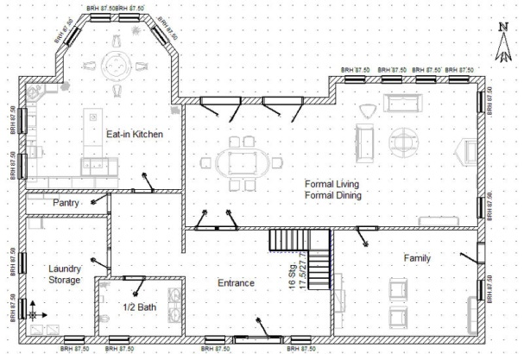  They could also use their own house, their school or a friend’s house if they prefer.  The teacher models how a table (or matrix) can represent a network diagram, and vice versa as follows:  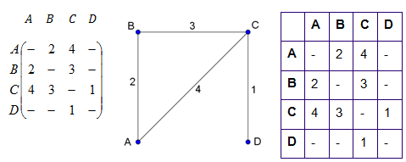  The teacher distributes a sheet with four tables similar to the one above. Students work in groups to draw network diagrams from those tables and share their results. The class discusses how correct answers may look slightly different (for example a rotation or reflection of the above diagram).  Students consider situations in which directed networks are appropriate, such as maps involving one-way streets, or water flowing down a pipe system from one point to the next. Students draw at least two connected network diagrams.  Students investigate how songlines and kinships in the Aboriginal and Torres Strait Islander cultures can be represented by networks, using the following website: http://religioneightaspects.weebly.com/aboriginal-spirituality.html  Students practise drawing different situations as network diagrams.
N1.2: Shortest paths  Students:  - determine the minimum spanning tree of a given network with weighted edges AAM  - determine the minimum spanning tree by using Kruskal’s or Prim’s algorithms or by inspection  - determine the definition of a tree and a minimum spanning tree for a given network | The teacher introduces students to the terminology of trees. Students make notes in the form of a glossary (possibly a poster if they wish), for example:  - A tree is a network, or part of a network that has no cycles (circuits).  - A spanning tree is a tree which contains every vertex in a network.  Students discuss circumstances in which a spanning tree would be useful, such as water mains or electricity mains layout for a housing estate.  Students watch the following video on Kruskal’s algorithm and make notes: https://www.youtube.com/watch?v=5XkK88VEILk  Students practise finding the minimum spanning tree using Kruskal’s algorithm on at least five weighted network diagrams. The teacher then shows the following video: https://www.youtube.com/watch?v=71UQH7Pr9kU and pauses it along the way for students to see if they can predict the next step using mini whiteboards.  Students watch the following video on Prim’s algorithm. The teacher pauses it intermittently for students to copy the diagram and produce their own notes. https://www.youtube.com/watch?v=cplfcGZmX7I  This can then be consolidated by watching the following video:  https://www.youtube.com/watch?v=MaaSoZUEoos  The teacher then discusses that a table method can also be used for Prim’s algorithm and shows the following video: https://www.youtube.com/watch?v=Pn874kEc3IA  Students repeat the process with tables of networks for at least four tables.  Students practise finding the minimum spanning trees for a variety of networks using both Kruskal’s and Prim’s algorithm.
- find a shortest path from one place to another in a network with no more than 10 vertices AAM  - identify a shortest path on a network diagram  - recognise a circumstance in which a shortest path is not necessarily the best path or contained in any minimum spanning tree | The teacher hands out string and key rings to students seated in groups. Students model the following network diagram using string (representing the edges) tied to key rings (representing the vertices). Strings should be cut to the length of each edge weight, and key rings should be labelled with the letter of the vertex they represent.  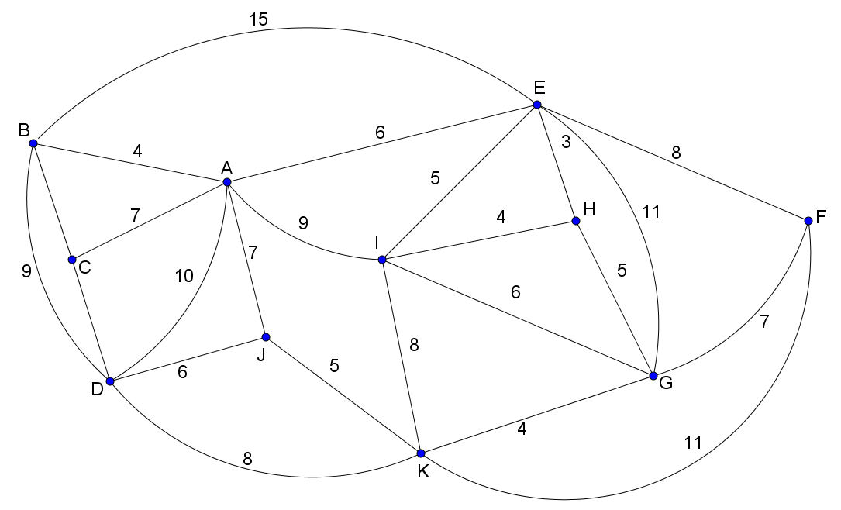  Students complete the following activity:  - To find the shortest path between C and H, pull the two key-rings tight apart. The shortest path is shown by the tight strings.  - Discuss the limitations of this type of physical model. Is it sensible to use for small networks? Is it practical to use for large networks? When might it be most useful?  - Find the shortest path from G to A in the network without using the string model.  - Share the shortest paths found from G to A with other groups and compare results.  - Find the shortest paths from B to F, C to E and G to B in the network.  - Develop a strategy for finding the shortest path, and check each answer using the string method.  The teacher leads a discussion in which the strategies for finding the shortest path are gathered together (using an online class webpage or a board at the front of the room).  The teacher develops the following method of finding the shortest path from the summary gathered above:  - To find the shortest path from A to J in a network follow this sequence of steps:  - Redraw the network diagram, with circles at each vertex except for $A$.  - For all vertices one step away from $A$, write down the shortest distance inside a circle representing the closest vertex.  - For all vertices two steps away from $A$, write down the shortest distance from $A$ inside each circle representing a vertex.  - Continue this way until $J$ is reached.  - The shortest path can then be identified by starting at $J$ and moving back to the vertex from which the minimum value at $J$ was obtained, then continue this until $A$ is reached.  This can be demonstrated using the following example:  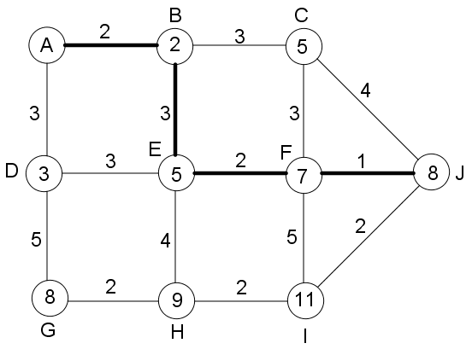  The shortest path is $ABEFJ$ and has a value of 8.  Students note this method, and practise finding shortest paths on a number of networks, using a textbook or worksheet such as:  http://www.google.com.au/url?sa=t&rct=j&q=&esrc=s&source=web&cd=2&ved=0ahUKEwiJotbO7-bTAhWEwrwKHZDMCuUQFggtMAE&url=http%3A%2F%2Fwww.jaconline.com.au%2Fmathsquestqld%2Fyear12a%2Fworksheets-ans%2FMQA-07-WS-1.doc&usg=AFQjCNH0NwPeE5yIAGOIaLBybclq0T6FUw&sig2=ayL1Vm1t2o_m8BHaf2NbGQ

Prior knowledge | Questions and prompts for Working Mathematically | Summary of technology opportunities
Familiarity with maps and house plans. | What must be added/removed/altered in order to allow/ensure …?  Is … an example of …?  Provide one or more examples of …  Describe all possible … as succinctly as possible.  How is … used in…?  Explain why …  What can change and what has to stay the same so that … is still true? | Various websites and YouTube videos.  A class webpage to pool ideas when investigating the shortest path techniques.  Investigating the use of networks online.

Reflection on learning and evaluation – to be completed by teacher during or after teaching the unit.

