Stage 6 Science

A Guide to Depth Studies
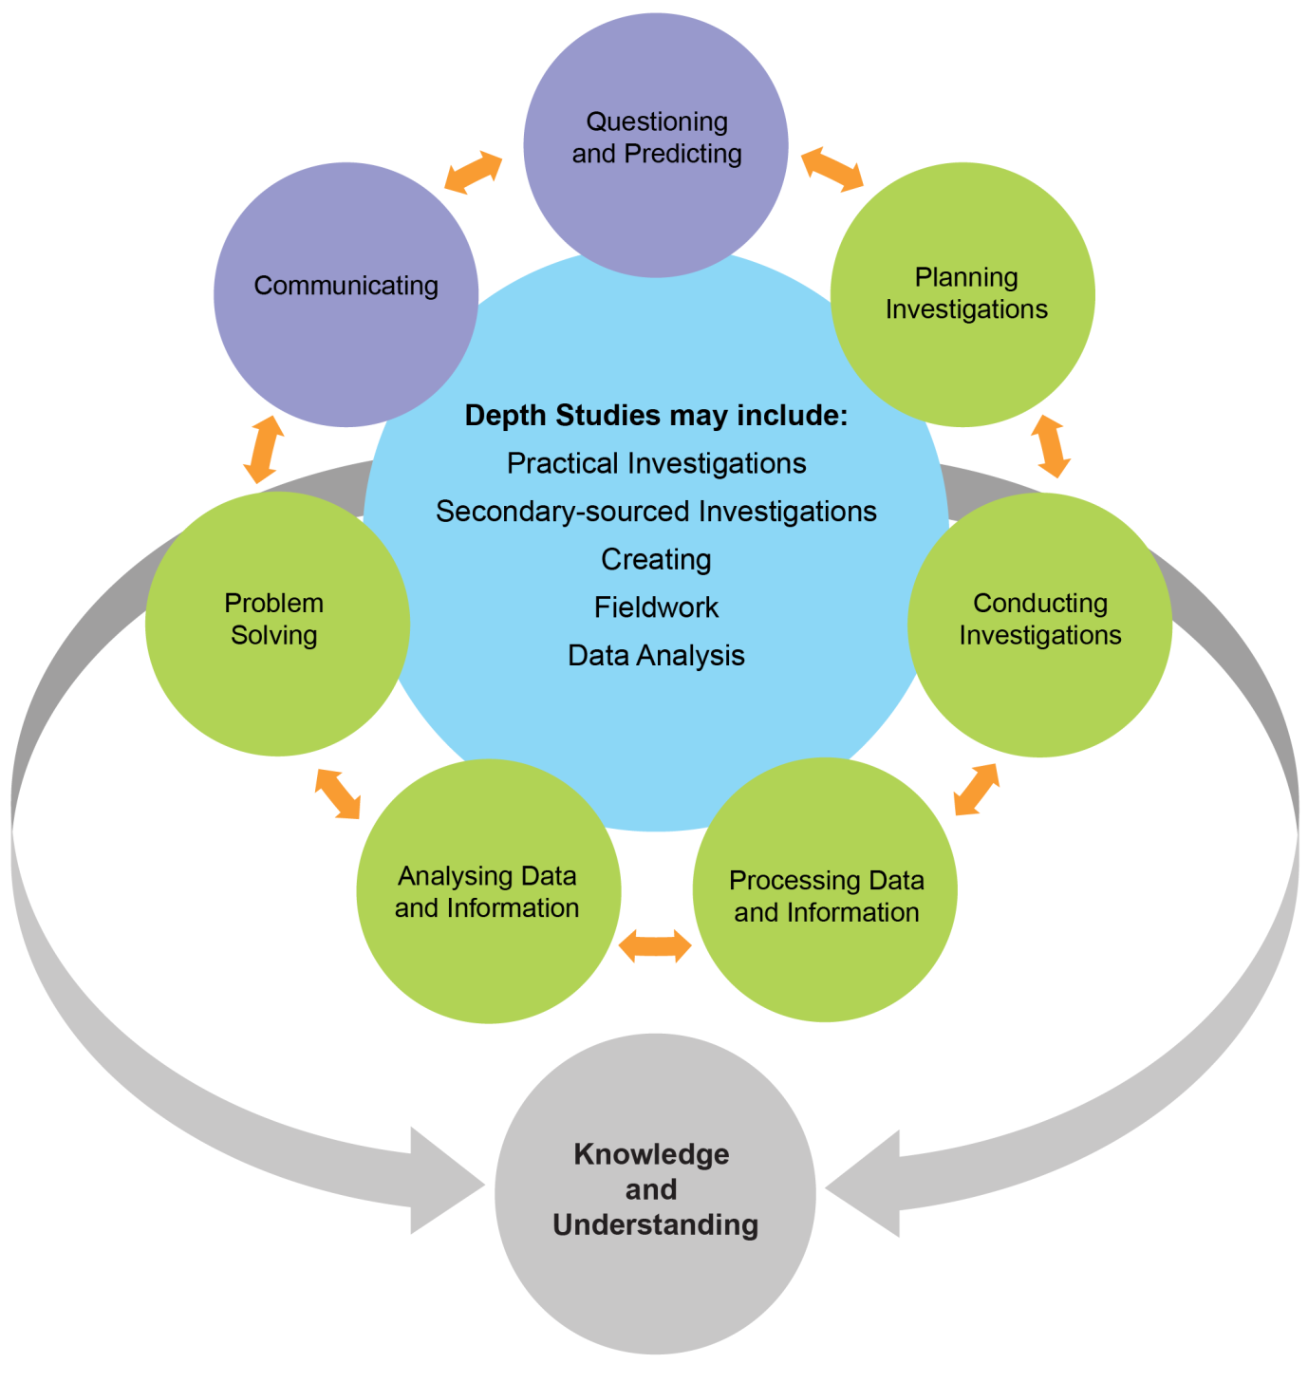

© 2018 NSW Education Standards Authority (NESA) for and on behalf of the Crown in right of the State of New South Wales.
The NESA website holds the ONLY official and up-to-date versions of these documents available on the internet. ANY other copies of these documents, or parts of these documents, that may be found elsewhere on the internet might not be current and are NOT authorised. You CANNOT rely on copies from any other source.
The documents on this website contain material prepared by NESA for and on behalf of the Crown in right of the State of New South Wales. The material is protected by Crown copyright.
All rights reserved. No part of the Material may be reproduced in Australia or in any other country by any process, electronic or otherwise, in any material form, or transmitted to any other person or stored electronically in any form without the prior written permission of NESA, except as permitted by the Copyright Act 1968.
When you access the material you agree:
- to use the material for information purposes only
- to reproduce a single copy for personal bona fide study use only and not to reproduce any major extract or the entire material without the prior permission of NESA.
- to acknowledge that the material is provided by NESA.
- to include this copyright notice in any copy made
- not to modify the material or any part of the material without the express prior written permission of NESA.
The material may contain third-party copyright materials such as photos, diagrams, quotations, cartoons and artworks. These materials are protected by Australian and international copyright laws and may not be reproduced or transmitted in any format without the copyright owner’s specific permission. Unauthorised reproduction, transmission or commercial use of such copyright materials may result in prosecution.
NESA has made all reasonable attempts to locate owners of third-party copyright material and invites anyone from whom permission has not been sought to contact the Copyright Officer.
Phone:(02) 9367 8289
Fax: (02) 9279 1482
Email: mila.buraga@nesa.nsw.edu.au
Published by
NSW Education Standards Authority
GPO Box 5300
Sydney NSW 2001 Australia
educationstandards.nsw.edu.au
DSSP – 28530
D2018/2471

Depth studies
From Year 11, 2018 the Stage 6 Biology, Chemistry, Earth and Environmental Science, Physics and Investigating Science syllabuses include the requirement for depth studies.

What is a depth study?
Each Stage 6 Science syllabus contains the following information about depth studies.
A depth study is any type of investigation/activity that a student completes individually or collaboratively that allows the further development of one or more concepts found within or inspired by the syllabus. It may be one investigation/activity or a series of investigations/activities.
- Depth studies provide opportunities for students to pursue their interests in Science, acquire a depth of understanding, and take responsibility for their own learning.
- Depth studies promote differentiation and engagement, and support all forms of assessment, including assessment for, as and of learning.
- Depth studies allow for the demonstration of a range of Working Scientifically skills.
A depth study may be, but is not limited to:
- a practical investigation or series of practical investigations and/or a secondary-sourced investigation or series of secondary-sourced investigations, presentations, research assignments or fieldwork reports
- the extension of concepts found within the course, either qualitatively and/or quantitatively.’
Depth studies are designed to provide opportunities for students to:
- consolidate their learning
- develop competence and confidence in relation to their knowledge and skills
- foster creativity by allowing students to apply their knowledge and skills to new situations.
Time is the essential element required for students to consolidate their learning, develop their competence and confidence, and to foster creativity.

Time allocated
In both Year 11 and Year 12 the following amount of time for depth studies must be identified in the scope and sequence for each Stage 6 Science course. This time may appear as a single block or may be represented by several blocks of time throughout the course determined by the teacher taking into consideration the needs of their students.
15 hours for:
- Biology
- Chemistry
- Earth and Environmental Science
- Physics
30 hours for:
- Investigating Science

Programming a depth study
The length of time for any individual depth study and the teaching and learning strategies to be employed are not prescribed to allow for flexibility in their design and delivery.
A depth study may be broken down over the year into smaller component depth studies, which may or may not be related. Only one assessment of a depth study, or a component of it, is required. Smaller components should not be assessed separately.
The following examples illustrate different ways that time may be allocated to depth studies in the scope and sequence.

Sample scope and sequences

A single depth study

Example 1
In this example, the depth study is completed at the end of the course and may include Knowledge and Understanding outcomes and skills.
The depth study here is standalone and allows for a final school-based assessment task to be administered at the end of the course.
As this is a single depth study it must be designed to assess at least five outcomes including the mandated outcomes as required by the syllabus.
Note the reduction of time across all the modules from 30 hours to accommodate the 15 hours required for the inclusion of the depth study.
Academic Year (not to scale)
Module 1  27 hrs | Module 2  26 hrs | Module 3  26 hrs | Module 4  26 hrs | Depth Study  15 hrs  (Includes assessment)

Example 2
In this example the depth study is sequenced, allowing the knowledge and understanding outcomes from Modules 1 and 2 to be addressed. This model may be used to assess the knowledge, understanding and skills outcomes from Modules 1 and/or 2.
As this is a single depth study it must be designed to assess at least five outcomes including the mandated outcomes as required by the syllabus.
Academic Year (not to scale)
Module 1  25 hrs | Module 2  20 hrs | Depth Study  15 hrs  (Includes assessment) | Module 3  30 hrs | Module 4  30 hrs

Multiple depth studies

Example 3
This example demonstrates how the 15 hours allocated to depth studies can be split across the academic year. The depth studies may be standalone or related. Any number of outcomes may be addressed across the three studies. As Depth Study 3 is indicated as the formal school-based assessment, the task must be designed to assess at least five outcomes including the mandated outcomes as required by the syllabus.
Academic Year (not to scale)
Module 1  25 hrs | Depth Study 1  5 hrs | Module 2  25 hrs | Depth Study 2  5 hrs | Module 3  25 hrs | Depth Study 3  5 hrs  (Includes assessment) | Module 4  30 hrs

Example 4
In this example 11 hours is allocated to the depth study in the first half of the year. The time may be used to consolidate students’ depth of knowledge of the fundamental concepts in the course or to build competence and confidence in Working Scientifically.
The later depth study may look at one module or concentrate on selected concepts from Modules 1, 2 or 3. As Depth Study 2 is indicated as the formal school-based assessment, the task must be designed to assess at least five outcomes including the mandated outcomes as required by the syllabus.
Academic Year (not to scale)
Module 1  24 hrs | Module 2  25 hrs | Depth Study 1  11 hrs | Module 3  26 hrs | Depth Study 2  4 hrs  (Includes assessment) | Module 4  30 hrs

Example 5
In this example, the allocated time for the depth study is distributed across all the Modules allowing time for the knowledge and understanding and skills outcomes to be programmed in context and/or in greater depth.
This also provides means for the development of a portfolio of learning that may culminate in a submitted article of work or project. As Depth Study 4 is indicated as the formal school-based assessment, the task must be designed to assess at least five outcomes including the mandated outcomes as required by the syllabus.
Academic Year (not to scale)
Module 1  27 hrs | Depth Study1  3 hrs | Module 2  27 hrs | Depth Study2  3 hrs | Module 3  27 hrs | Depth Study3  3 hrs | Module 4  24 hrs | Depth Study4  6 hrs  (Includes assessment)

Example 6
In this example, the depth study is run concurrently with all the modules across the academic year. Teachers may set time per fortnight specifically for the development of students’ scientific knowledge or application of the Working Scientifically skills.
A formal school-based assessment task for the depth study can occur at an appropriate time throughout the academic year.
Academic Year (not to scale)
Module 1  27 hrs | Module 2  26 hrs | Module 3  26 hrs | Module 4  26 hrs
Depth Study 15 hrs
(Includes assessment)

Assessment of a depth study
The requirements for a depth study are described in the syllabuses for the Stage 6 Science courses. The requirements for the assessment of depth studies are found in the subject-specific Assessment and Reporting in Science Stage 6 document.
It is important to understand that undertaking depth studies and assessing a depth study, or an aspect of it, are distinct. The assessment of depth studies should focus only on the five outcomes required by the syllabus. Assessment need not assess every outcome addressed throughout the depth study.
The following is taken from Assessment and Reporting in <Science> Stage 6:
A depth study may be a single investigation/activity or series of investigations/activities. The depth study may be designed for the course cohort or a single class or be determined by individual students.
While the depth study may be undertaken in a single module of the course or across modules, the formal assessment of a depth study, or aspect of the study, must only occur once. The design of the assessment task must provide opportunities for all students to demonstrate their knowledge, understanding and skills of the outcomes using a common marking criteria and guidelines regardless of their area of investigation.
A range of task types may be used when assessing a depth study or an aspect of a depth study. In many cases, a report that explains the process undertaken throughout the depth study with an analysis of the final product or result will be an appropriate format for an assessment task. Other examples include written reports, oral presentations, digital or multimedia products, data analysis, practical investigations or fieldwork.
Teachers are encouraged to incorporate constructive feedback throughout the depth studies and support collaborative learning conversations.

Depth study assessment requirements
In both Year 11 and Year 12 the requirements for assessing depth studies are:
- one task must focus on a depth study or an aspect of a depth study with a weighting of 20–40%
- the depth study task must assess:
  - the Working Scientifically skills outcomes:
– Questioning and Predicting
– Communicating
- a minimum of two additional Working Scientifically skills outcomes
  - at least one Knowledge and Understanding outcome.

Frequently asked questions

Are additional provisions required for depth studies?
No. The parameters surrounding depth studies are school-based provisions. No pedagogy is prescribed thus allowing schools flexibility to address the requirements.
The achievement of the course outcomes is not dependent on the specific provisions and resources available for the students.

Is every student required to complete a 15-hour depth study project?
No. The design of depth studies is not mandated and may take a variety of forms. This need not be a single project. The examples in this document outline ways to program depth studies.

How will the depth study be assessed?
Teachers will plan and implement the depth study task and assess it as one formal school-based assessment task. The depth study assessment task has weighting of 20-40% and must assess the five outcomes as stipulated in the Assessment and Reporting in <Science> Stage 6 document.

How can we fit depth studies into our busy timetable?
The reduction in content in the development of the new Stage 6 Science courses allows time for the depth studies. The depth studies provide opportunities for students to increase the depth of their knowledge and/or to explore relevant areas of interest in science.

What if the student chooses a depth study topic that is not in my area of expertise?
Teachers do not need to be experts in the area chosen by their students. The teacher’s role is to facilitate, guide and support their students as they explore concepts in greater depth. They assist students with mastering scientific processes and the Working Scientifically skills. The teacher may choose or direct the area for depth studies.

How can cheating and plagiarism be avoided with depth studies?
All students complete the online course All My Own Work. Schools have their own policies in dealing with cheating and plagiarism and the introduction of depth studies should follow the same rules that each school has in place. There are online software programs that can be used to identify plagiarism. However, it is important to remember that depth studies are not solely about assessment.

Can students develop the same/similar depth study if they are studying more than one Science subject?
The purpose of a depth study is to expand students understanding of scientific concepts while demonstrating Working Scientifically skills, and this is partially course-specific. In a practical sense the skills will be transferable, but are developed within the context of the course studied. Therefore, to fulfil the course requirements, each course must have documentation of the students’ depth study/studies for that course only. The formal assessment of the depth study/studies must address at least one specific Knowledge and Understanding outcome for that course.
Completing only one task for both Science subjects will not fulfil the assessment requirements set down in the Assessment Certification Examination (ACE) Manual
Projects developed for assessment in one subject are not to be used either in full or in part for assessment in any other subject. (Ace 8013).

Can students use their depth study/studies for the Scientific Research Project in Science Extension?
A student may take inspiration from their depth study/studies undertaken in a 2 Unit Science course. However, the course requirements and outcomes are different for the 2 Unit Science courses and Science Extension. Students studying Science Extension are expected to extend their Scientific Research and Working Scientifically skills to a level greater than that required for the 2 Unit courses.
Additionally, the Scientific Research Project and the depth study/studies both require separate formal school-based assessment as outlined above and in the ACE manual.

