Mathematics Standard 1 Year 12

Sample Assessment Task

Applications of Networks: Computer Cable Analysis
Sample for implementation for Year 12 from Term 4, 2018

Context
Students have engaged in learning for the subtopic, Networks and Paths. They have participated in activities to develop knowledge of the concepts of networks and finding the minimum spanning tree, and skills to solve a variety of problems.
Students will require approximately four hours of independent preparation, at least one hour of which should be spent in class; including class time to discuss the notification and task requirements.
The task notification includes five parts. The parts as well as marking criteria will be handed out with the notification.

Notes to teacher
Throughout the development of this task, teachers should monitor authorship and the progress of student work. All responses will be submitted on the same day.
When individual feedback is provided after marking, there will be opportunity to discuss the challenges of the task with the class and consider future learning activities to assist student learning.

Computer Cable Analysis
Task number: 3 | Weighting: 30% | Timing: Term 2, Week 8

Outcomes assessed
- applies network techniques to solve network problems MS1-12-8
- chooses and uses appropriate technology effectively and recognises appropriate times for such use MS1-12-9
- uses mathematical argument and reasoning to evaluate conclusions, communicating a position clearly to others MS1-12-10

Nature of the task
This assignment involves the use of network theory to solve a real world problem.
All parts of the task are to be completed individually. When working during class time, students can access all class notes and practise questions. Students may access digital technologies during class time.

Marking criteria
You will be assessed on how well you:
- accurately solve a variety of problems based on the scenario
- select and use appropriate mathematical processes, technologies and language to investigate, organise and interpret networks
- provide reasoning and justification related to the problems.

Feedback provided
The teacher will provide feedback outlining strengths and areas for improvement to build on knowledge, understanding and skills for future learning.

Student Name:

Computer Cable Analysis

The following diagram is a plan of Mathmore High School showing buildings and paths.
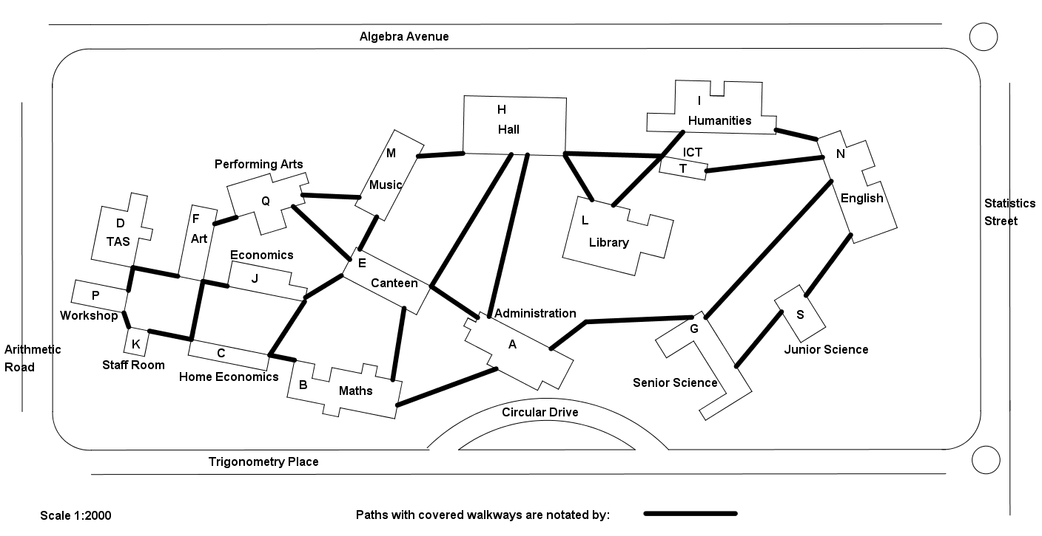
Throughout your working, always round all distances off to the nearest whole metre.

Understanding, Fluency and Communication (10 marks):
- Using the plan, draw a network diagram of all the buildings connected by covered walkways showing the actual distances (to the nearest metre) on your diagram.
- Each vertex will represent a building, and should be labelled with the appropriate letter.
- Each edge will represent a covered walkway, and should be labelled with the distance.
- The Department of Education wants to link the outside of each building to a computer network. Cable costs $45 per metre, and the existing covered walkways are to be used with cable attached to the roof of the walkways.
- They ask company A to submit a proposal. Design and cost the most economical cable network for company A. Draw up company A’s proposal, explaining your reasoning and justifying your working with calculations and network theory. Include a network diagram in your explanation.

Problem Solving, Reasoning and Justification (20 marks):
- In an effort to reduce the costs of cabling the school, the school executive decides that cable will be from Building P to Building N connecting only those buildings that are on the shortest path. They ask company B to submit a proposal for this. Find the shortest path from P to N, and cost this new cable network. Draw up company B’s proposal, explaining your reasoning and justifying your working with calculations and network theory. Include a diagram in your explanation, and note the buildings that would not be included as part of the computer network in this proposal.
- The school asked company C to consider the issues and submit a proposal for the construction. Company C decides that they will charge $55 per metre for computing cable if it is laid in trenches which they dig, rather than using the covered walkways. The trenches would use the shortest possible distance between buildings and all buildings would be connected via trenches so they would be connected in the computer network. Draw up company Cs proposal, including a network diagram of the trenches that would need to be dug, and a costing. Justify your answer with calculations and network theory.
- Imagine you are on the school executive. Which of the three proposals would you accept and why?

End of task

Marking guidelines
The five parts of the marking guidelines align with the five task parts.
Part 1 – Understanding, Fluency and Communication | Marks
- Measures and converts at least five actual distances from original diagram  - Displays the vertices on network diagram labelled A to T  - Represents all edges correctly  - Displays correct measurements on all edges | 1  1  1  1

Part 2 – Understanding, Fluency and Communication
- Indicates the correct costing calculation (for example, network diagram redrawn with costings on edges)  - Demonstrates a clear attempt at finding the shortest spanning tree  - Displays a correct shortest spanning tree  - Indicates the correct minimal cost  - Communicates clearly the process for finding the shortest spanning tree  - Communicates the company’s proposal clearly | 1  1  1  1  1  1

Parts 3 and 4 – Problem Solving, Reasoning and Justification  (9 marks each, marked separately) | Marks
A student:
- demonstrates a thorough understanding of the mathematics involved in solving the problem  - uses appropriate mathematical processes in solving the problem without error  - communicates in a concise and systematic manner and justifies conclusions using appropriate mathematical language, diagrams, notation and symbols | 8–9
- demonstrates understanding of the mathematics involved with appropriate calculations with either a minor arithmetic or calculation error OR all mathematical calculations have been carried out without error but the final conclusion is incorrect  - communicates in a concise and systematic manner and justifies conclusions using some mathematical language, diagrams, notation and symbols | 6–7
- demonstrates progress towards a solution with some error  - demonstrates a developing understanding of what it means to work mathematically with some use of mathematical language, diagrams, notation and symbols | 4–5
- demonstrates a limited understanding of the mathematics involved in solving the problem  - demonstrates a limited use of mathematical language or diagrams | 1–3

Comparison of proposals
Part 5 – Problem Solving, Reasoning and Justification | Marks
- Makes a correct comment regarding a comparison of cost  - Makes a correct comment regarding a comparison of meeting the needs of the school | 1  1

