Mathematics Standard 2 Year 12
Measurement Topic Guidance

Mathematics Standard 2 Year 12 Measurement Topic Guidance
Topic focus 3
Terminology 3
Use of technology 3
Background information 4
General comments 4
Future study 4
Subtopics 4
MS-M6: Non-right-angled Trigonometry 5
Subtopic focus 5
Considerations and teaching strategies 5
Suggested applications and exemplar questions 5
MS-M7: Rates and Ratios 6
Subtopic focus 6
Considerations and teaching strategies 6
Suggested applications and exemplar questions 7

Topic focus
Measurement involves the application of knowledge, skills and understanding of number and geometry to quantify and solve problems in practical situations.
Knowledge of measurement enables an understanding of basic daily situations involving rates and ratios, such as speed and the interpretation of maps and plans, effectively in a variety of situations.
The study of measurement is important in developing students’ ability to solve problems related to two and three-dimensional models and representations and to work effectively with a variety of rates and ratios.

Terminology
acute angle  aerial photograph  ambiguous case  angle of depression  angle of elevation  area  area of a triangle  best buy  building plans  compass bearing  compass radial survey  cosine rule  cultural mappings  elevation views | energy  energy rating  fuel consumption rate  heart rate  International System of Units  joule  map scale  navigational error  non-right-angled triangle  obtuse angle  peak rate  perimeter  power  Pythagoras’ theorem | radial survey  rate  ratio  scale drawing  sine rule  site plan  speed  targeted heart rate  Trapezoidal rule  trigonometric ratio  true bearing  volume  watt

Use of technology
Australian Institute of Health and Welfare data can be accessed on the internet.
Teachers can use appropriate technology to provide students with local-area examples of aerial photographs for calculations, for example, calculate the perimeter of a playing field or the area of an irregular-shaped field.
Google Maps is an online resource that can be used to access maps and scaled aerial photographs, and to calculate distances on land. Online distance calculators and a ruler could also be used to determine the scale of a photograph.
Aerial photographs of lakes or dams, combined with research about their depths, can be used to make volume calculations.

Background information
Almost all early civilisations used the shadow cast by a vertically positioned stick to observe the motion of the Sun and tell time. This instrument is now called a Gnomon, the Greek name of an L-shaped instrument used to draw a right angle.
The foundations of trigonometry were laid as early Babylonian, Greek, Hellenistic, Indian, and Arabic mathematicians investigated astronomical problems using numerical and geometric techniques, specifically the geometry of the circle. The most literal meaning of ‘trigonometry’ comes from the Greek words for ‘triangle’ and ‘measure’. Trigonometry was established as a distinct branch of mathematics during the 12th and 13th centuries.
Herophilos (335–280 BC), a Greek physician and scientist was the first to publish information about heart rates. It was not until the invention of a stopwatch in 1707 that heart rates could be measured accurately.

General comments
Students should be encouraged to ‘estimate and check’ to determine if results are reasonable. This is a skill that should be reinforced throughout the Measurement strand.
Practical applications of the concepts studied should be investigated, for example the use of compass radial surveys in surveying.
Students are not expected to reproduce proofs of the sine, cosine and area rules.
Students can be shown that when a triangle is right-angled, the cosine rule becomes Pythagoras’ Theorem, the area formula becomes simply ‘half base times perpendicular height’ and the sine rule becomes an application of the sine ratio in a right-angled triangle.
Materials used for teaching, learning and assessment should include current information from a range of sources, including, but not limited to, newspapers, journals, magazines, real bills and receipts, and the internet.
Electricity is a fundamental resource in modern life, so students should solve a variety of problems based on the consumption of household electricity.

Future study
The skills and concepts students encounter in this topic will be further developed and applied practically in many of the post school contexts and training areas that students may follow. This topic will also provide students with the skills they will need to solve the practical problems that arise when managing a household or engaging in leisure activities.

Subtopics
- MS-M6: Non-right-angled Trigonometry
- MS-M7: Rates and Ratio

MS-M6: Non-right-angled Trigonometry

Subtopic focus
The principal focus of this subtopic is to solve problems involving right and non-right-angled triangles in a variety of contexts.
Students develop their ability to justify mathematical thinking and communicate solutions in an ordered and concise fashion.
Within this subtopic, schools have the opportunity to identify areas of Stage 5 content which may need to be reviewed to meet the needs of students.

Considerations and teaching strategies
- In this topic, the approximation of angles includes approximation to the nearest minute.
- For problems involving applications of the sine rule where an angle is to be found, any solutions should only involve acute angles.
- The cosine rule should be presented in each of the forms:$c^{2}=a^{2}+b^{2}-2ab cos C$ and $\cos{C}=\frac{a^{2}+b^{2}-c^{2}}{2ab}$.
- In problems that involve the sine rule, cosine rule or the area of a non-right-angled triangle, diagrams should be provided.
- Diagrams should be provided for problems involving angles of elevation and depression, bearings, and for problems involving two triangles.

Suggested applications and exemplar questions
- Students estimate the area and perimeter of a part of the school grounds. They then carry out a compass radial survey and complete a scale diagram, which they use to calculate the area and perimeter. Students present, compare and discuss their results.
- Students plan a walk or another type of journey by reading and interpreting a map.
- Students find gradients from contour lines on maps.
- Navigational charts can be used to plan routes and identify positions.
- Students can calculate the heights of buildings and other structures.
- The derivation of formulae used in this topic can be investigated.
- Examples of ‘two-triangle problems’ to be solved include:
The angle of depression from J to M is 75°. The length of JK is 20 m and the length of MK is 18 m.
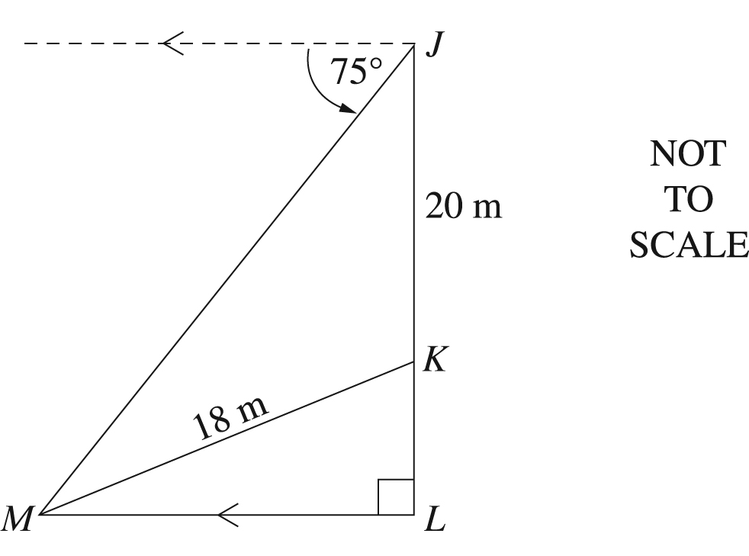
Calculate the angle of elevation from M to K. Give your answer to the nearest degree.

- The area of the triangle shown is 250 cm².
30 cm

28 cm

$x$ cm

44°

NOT TO SCALE

What is the value of $x$, correct to the nearest whole number?
(A) 11 (B) 18 (C) 22 (D) 24

MS-M7: Rates and Ratios

Subtopic focus
The principal focus of this subtopic is on the use of rates and ratios to solve problems in practical contexts, including the interpretation of scale drawings.
Students develop awareness of the use of rates and ratios and solve problems in everyday situations, such as health sciences, energy and finance.
Within this subtopic, schools have the opportunity to identify areas of Stage 5 content which may need to be reviewed to meet the needs of students.

Considerations and teaching strategies
- Students should be able to make conversions between units for rates over two dimensions, for example length and time, including km/h to m/s.
- The watt is the International System of Units (SI) derived unit of power and is equal to one joule per second. By definition power is a rate. The symbol for the watt is W.
- The energy consumption of common appliances and physical activities can be ranked by students.
Examples that could be used include:
  - a typical household incandescent light bulb uses 40 to 100 watts
  - a person climbing a flight of stairs is doing work at up to approximately 200 watts
  - a highly-trained athlete can work at up to approximately 2000 watts for brief periods
  - a car engine produces approximately 25 000 watts while cruising.
- One watt-hour is the amount of energy expended (usually electrical) by a one-watt load (for example a light bulb) drawing power for one hour. The watt-hour (symbol W·h or Wh) is a unit of energy. It is most commonly used on household electricity meters in the form of the kilowatt-hour (kW·h or kWh), which is 1000 watt-hours.
- Quantities and units may be expressed in both decimal form and standard notation, for example 6.8 × 10³ MW or 6 800 000 kW.

- Conversion of units is to be based on the following table:

Table of units
Multiple | Name | Symbol
10^{–3} | milliwatt | mW
10⁰ | watt | W
10³ | kilowatt | kW
10⁶ | megawatt | MW
10⁹ | gigawatt | GW

- Building plan dimensions are expressed in millimetres.
- Scale diagrams should include house plans and maps. Online maps are readily available (with measurement tools) for extension activities.
- The dimensions of the room and the width of the carpet should be considered when deciding in which direction to lay the carpet in order to minimise wastage and the number of joins.
- Trapezoidal rule problems involving four strips should be treated through two applications of the rule. The problems addressed could be extended to include the calculation of volume given the relevant dimensions.
- Rainfall data is widely available on the internet. Useful information and data can be found at the Australian Bureau of Meteorology and Sydney Water websites. The spreadsheet below provides an example of how rainfall data on the Australian Bureau of Meteorology website is tabulated.
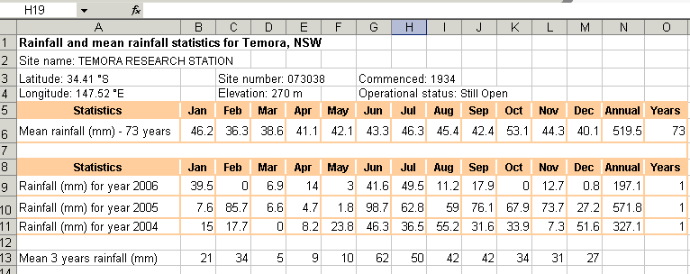

Suggested applications and exemplar questions
- Calculate rates of application of chemicals used in agriculture, for example rates for pesticides and feed additives.
- Calculate distances and travelling times from maps.
- Calculate and compare running costs for similar vehicles using different types of fuel, eg calculate and compare the running costs of a particular vehicle using petrol, diesel, or liquefied petroleum gas (LPG).
- Calculate the yearly fuel consumption and the yearly cost of petrol for various classes of vehicle, for example a car with a 4 cylinder, 1.6 L engine compared to one with a 6 cylinder, 4 L engine, given their fuel consumption rate in litres per 100 kilometres.
- Calculations of running costs of various appliances, for example:
1. Calculate the cost of running a 200-watt television set for six hours if the average peak rate for domestic electricity is $0.15/kWh.
Solution:
Total electricity used = 200 × 6 = 1200 watt-hours or 1.2 kWh.
Cost of electricity used is 1.2 kWh × $0.15/kWh = $0.18.

2. Calculate the cost of running a 2400-watt (2.4 kW) fan heater for eight hours per day for 30 days. Assume electricity is charged at $0.18/kWh.
Solution:
Total electricity used = 2.4 × 8 × 30 = 576 kWh.
Cost of electricity used is 576 kWh × $0.18/kWh = $103.68.
- If it costs 15 cents for 1-kilowatt (1000 watts) for one hour, how much would it cost for a 2400-watt heater to be on from 5 pm to 11 pm?
- Data in relation to worldwide electricity consumption is available on the internet. Students can extract data from tables or graphs and interpret this information in order to compare electricity consumption in different countries.
- Modify given recipes by varying quantities to provide for various numbers of people.
- Calculate the quantity of each component needed for a fertilising operation, given the ratio of the components in the mixture.
- Students accurately construct a scaled floor plan of the classroom.
- Find ceiling heights from building plans.
- Calculation of area and volume based on information on a plan needs to include, for example:
  - finding the area of a house to be carpeted and the cost of purchasing the carpet
  - calculating the area to be painted and the cost of painting a room in a house
  - calculating the volume of the rooms in a house and using a table to determine the appropriate-sized air conditioner for the house.
- Use rainfall data available on the internet to calculate the approximate volume of water that falls on a roof during a given period of time.
- Download a satellite map or other scale diagram from the internet and identify a geographical feature that has an irregular boundary, for example a lake or field. Use the scale of the map or diagram to calculate actual dimensions of the feature. Apply a formula such as the Trapezoidal rule to estimate the area of the feature.
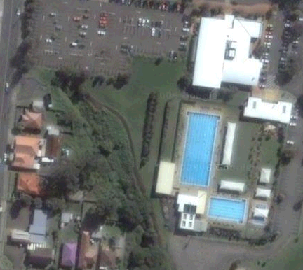
- On a map or aerial photograph some features have known dimensions and can be used to estimate lengths or distances and to find the scale of the map or photograph, for example an Olympic swimming pool, an athletics field, or a playing field for a particular sport.

- Online tools such as those on the Google Maps website can be used to determine distances on the surface of the Earth.
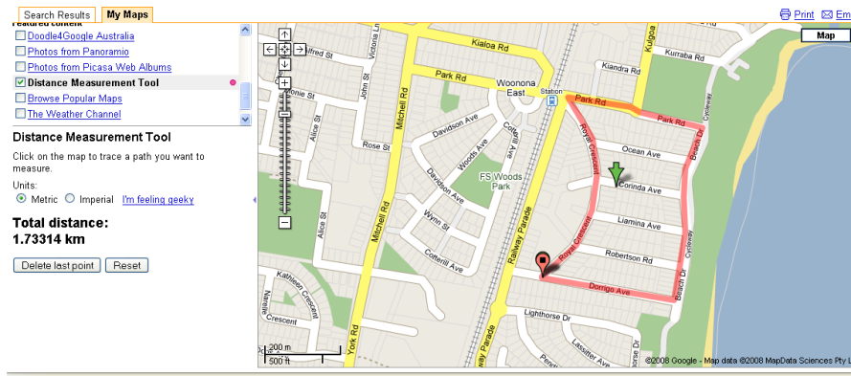
- The following estimation methods could be used to calculate the approximate area of a piece of land, a catchment (drainage basin), or a dam:
- the grid-square method
- the polygon method
- the Trapezoidal rule.

