Mathematics Standard Year 11
Financial Mathematics Topic Guidance

Mathematics Standard Year 11 Financial Mathematics Topic Guidance
Topic focus 3
Prior learning 3
Terminology 3
Use of technology 3
Background information 4
General comments 4
Future study 5
Subtopics 5
MS-F1: Money Matters 5
Subtopic focus 5
F1.1 Interest and depreciation 5
Considerations and teaching strategies 5
Suggested applications and exemplar questions 6
F1.2: Earning and managing money 7
Considerations and teaching strategies 7
Suggested applications and exemplar questions 7
F1.3: Budgeting and household expenses 8
Considerations and teaching strategies 8
Suggested applications and exemplar questions 8

Topic focus
Financial Mathematics involves the application of knowledge, skills and understanding of numbers to earning, spending, investing, saving and borrowing money.
Knowledge of financial mathematics enables students to analyse different financial situations, to calculate the best options for given circumstances, and to solve financial problems.
The study of financial mathematics is important in developing students’ ability to make informed financial decisions, to be aware of the consequences of such decisions, and to manage personal financial resources effectively.

Prior learning
The material in this topic builds on content from the Number and Algebra Strand of the K–10 Mathematics syllabus, including the Stage 5.1 and 5.2 substrands of Financial Mathematics and Linear Relationships.

Terminology
allowable tax deductions  allowance  annual leave  annual leave loading  asset  book value  budget  commission  compound interest  compounding period  comprehensive insurance  compulsory insurance  deduction  depreciation  depreciation schedule  discount  discretionary spending  fixed spending  fuel consumption rate  goods and services tax (GST)  gross income  gross pay | income  income tax  interest  interest rate  loan repayment  loss  market value  Medicare levy  net pay  non-compulsory insurance  on-road costs  original price (or cost)  overtime  Pay As You Go (PAYG)  payment summary  penalty rate  pension  percentage  period  piecework  profit  recurrence relation | refund  royalty  running costs  salary  sale price  scrap value  simple interest  sliding scale  stamp duty  straight-line method  superannuation  tax deduction  tax instalment  tax payable  tax return  tax scale  taxable income  third-party insurance  useful life  vehicle registration  wage  wage-sheet

Use of technology
Spreadsheets are widely used in the workplace, particularly in the business and finance sectors. Students may construct and use spreadsheets to perform particular tasks, including calculation of wages and overtime, preparation of personal and family budgets, planning for future purchases and tracking investments.
Spreadsheets allow the user to perform ‘what if’ analyses, for example to compare the financial effects of different purchase decisions on a budget.
Students can use prepared spreadsheets to determine Pay As You Go (PAYG) income tax and the Medicare levy for different taxable incomes.
The internet can be used to provide up-to-date financial information, for example interest rates, income tax scales, current values of vehicles, stamp-duty rates, fuel prices, and interest rates for personal loans.
Online calculators can be used to investigate income tax and explore the effect of changing circumstances on the amount to be paid.

Background information
The concept of charging interest has been attributed to ancient agricultural civilisations in which loans of grain could be repaid with ‘interest’ because the grain was self-reproducing. This concept was later applied to loans of commodities such as metals that could not ‘grow’ naturally.
Historically, some cultures have regarded compounding interest as an unethical practice that gives the lender an unfair advantage over the borrower. The practice of charging interest is still condemned by some present-day cultures.
Tables of compound interest values were used in the Middle Ages. By the late 16th century, publication of simple and compound interest tables was limited to a consideration of the effect of interest rates of 4%, 5% and 10%.
The quote ‘Compound interest is the eighth wonder of the world. He who understands it, earns it ... he who doesn't ... pays it’ is often attributed to Albert Einstein, although the earliest place the quote is recorded is in 1983. It has also been attributed to Benjamin Franklin and Baron Rothschild. Whoever said it, the quote illustrates the importance of compound interest in the development of finance over the centuries.

General comments
Where possible, students should be given the opportunity to model and explore practical situations in relation to the mathematics addressed in this topic area and relevant use of technology. Where it is not possible to provide practical experiences, the problems posed should be relevant to the lives of students.
This topic provides many opportunities for students to acquire and apply skills through extended real-life investigations. Interest areas could include for example, resource usage, food and nutrition, the human body, travel and sustainability.
In Stage 5, students solved Consumer Arithmetic problems involving earning and spending money, and the management of money. In the Financial Mathematics topic in the Year 11 course, students will develop these concepts further in relation to earning and managing money, investing money and taxation.
Learning and teaching in this topic should be supported by the use of real and up-to-date data, for example calculations of wages and salaries should include calculations in relation to current awards and work contracts.
The use of current information from a range of sources including, but not limited to, newspapers, journals, magazines, real bills and receipts, and the internet will allow students to model real-life situations.
Students should be familiar with correct terminology in this topic and be able to use this terminology when justifying or explaining their solutions to problems.

Future study
Further work on investment, depreciation and loans is studied in the Year 12 Mathematics Standard 1 course. In Mathematics Standard 2, students will also study annuities.
The Mathematics Standard 2 topic of Annuities will form part of the work in common with the Mathematics Advanced course.
Teachers may choose to introduce the terminology that students will encounter in Year 12 Financial Mathematics during their studies of the Year 11 content.

Subtopics
- MS-F1: Money Matters

MS-F1: Money Matters

Subtopic focus
The principal focus of this subtopic is to calculate and graph simple interest, manage earnings, wages and taxation, and develop an appropriate budget for a given situation.
Students develop an ability to justify various types of financial decisions which will affect their lives now and into the future.
Within this subtopic, schools have the opportunity to identify areas of Stage 5 content which may need to be reviewed to meet the needs of students.

F1.1 Interest and depreciation

Considerations and teaching strategies
- Review the use and application of percentages so students can explore, measure and make decisions related to financial situations including profit, loss, discount, and goods and service tax (GST).
- Goods and services tax (GST) calculations should include finding the GST amount, final cost and finding the original cost of goods before GST was added.
- Calculations of simple interest should include interest rates expressed other than as ‘per annum’.
- Review transposing or rearranging equations or formulas so students can determine the unknown variable such as $P$, $r$ or $t$ in the context of simple interest.
- Graph simple interest situations and explore what the gradient represents and use the graph to interpolate and extrapolate values.
- Use tables of relevant data or graphs to interpret financial situations and make decisions.
- Explore depreciation using the straight-line method (also referred to as flat rate or prime cost depreciation) as an application of simple interest. This could involve activities such as determining depreciation schedules and drawing book value vs time graphs.
- Explore and model the relationship of compound interest to simple interest. Software such as a spreadsheet can be used for calculations and graphing.
Eg Students could create and explore the following spreadsheet:
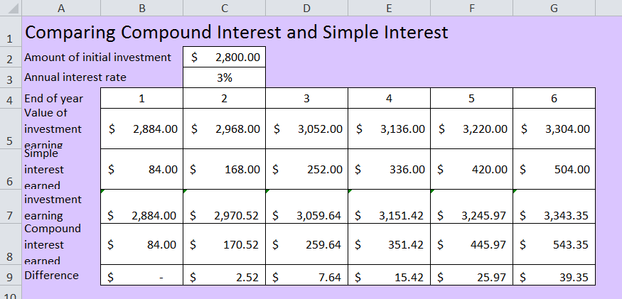
The formulae used to create this spreadsheet are as follows:
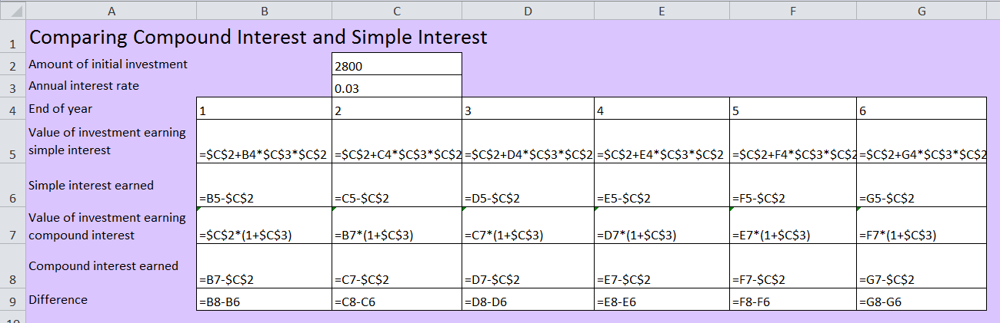
- Graphical comparison of simple interest versus compound interest investments should be considered and used to interpret financial situations and make decisions.
- Teachers can introduce the following terms at this stage: future value (FV) and present value (PV) in the context of repeated applications of the simple interest formula.

Suggested applications and exemplar questions
- The school uniform shop is having a back-to-school sale and is offering a discount on all its goods.
- What is the percentage discount on a shirt reduced from $52.50 to $42.00?
- Assuming the percentage discount is the same on all items in the uniform shop, find:
- the discount amount on a pair of pants whose original price was $36.00
- the sale price of a bag which originally cost $39.95.
- If the sale price of a blazer is $129.50, what was its original price and the discount?
- If the pre-GST price for a fridge is $900, what is the sale price inclusive of GST?
- If a computer was purchased for $2500, what was the amount of GST paid on this item and its pre-GST price?
- If the interest rate is quoted as 6% pa, what amount needs to be invested in order for the investment to be worth $850 at year’s end?
- It is predicted that a particular asset will depreciate at a rate of $80 per annum. Calculate its predicted value in ten years if it was purchased for $8000.
- A principal of $1000 is to be invested for three years. Use a spreadsheet to determine which of the following is the best investment option:
- 6% pa simple interest
- 5.9% pa compounded annually
- 5.85% pa compounded half-yearly.

F1.2: Earning and managing money

Considerations and teaching strategies
- Explore different additions to and deductions from gross pay.
- Investigate industrial awards and agreements of relevance to students. The list of awards can be found on the Australian Government Fair Work Ombudsman website.
- Tax and levy rates, as published on the Australian Taxation Office (ATO) website, should be used in the calculation of income tax and the Medicare levy.
- Calculations involving Youth Allowance, or its equivalent, should be based on the current published rates and conditions. The current advertised rates should be used in interest-rate calculations.
- Allowable tax deductions can include work-related expenses, travel expenses and donations to registered charities. Students should refer to current taxation information and consider tax deductions for different occupations.
- It should be noted that a graph of tax paid against taxable income is a piecewise linear function.

Suggested applications and exemplar questions
- Calculate earnings based on prepared timesheets.
- A programmer is paid an annual salary of $56 230. Calculate the equivalent hourly rate if an average week is 42 hours of work.
- A salesperson, earns a monthly commission of 5% of sales on the first $1000 of sales, 4% on the next $2000 and 3.5% thereafter (ie the commission is based on a sliding scale). Calculate the pay for a month in which total sales were $4800.
- Make a comparison of wages in various countries for different careers.
- Calculate the tax refund (or amount payable) based on a sample Payment Summary, taking into account gross income, tax deductions, taxable income, tax payable on taxable income, the Medicare levy, and tax already paid as per the Payment Summary.
- Students complete a tax return form (as included in the Tax Pack) using a typical PAYG employee’s earnings and deductions. The aim is to calculate the refund from or amount owed to the ATO.
- Students use an online tax calculator. For details, visit the ATO website.
- Students select a career and prepare a report that includes the educational requirements, job conditions, and remuneration. Students can obtain information from sources including newspapers, online job advertisements, and recruitment agencies. The report might also include calculation of net pay after tax.

F1.3: Budgeting and household expenses

Considerations and teaching strategies
- Explore the various ways organisations charge for their services and display this information. Services could include electricity, water, gas, internet and telephone or council rates.
- Use household documents to interpret information about a household’s energy and resource usage and to make informed financial judgments and decisions, for example, a household water, gas or electricity bill.
- Stamp duty is levied by the Office of State Revenue when a vehicle is registered to a new owner. Stamp duty is paid on the market value of the vehicle or the price actually paid, whichever is greater.
- Make calculations and comparisons of running costs of, for example, appliances or vehicles, using information from a table or graph.
- Budgeting should be set in personal contexts, as opposed to other contexts such as a family budget. Many students will be familiar with aspects of earning money through employment on a casual or part-time basis. Students should develop weekly and monthly budgets that include income, expenses and savings.
- When considering the cost of repairs by tradespeople this should include the cost of out-of-hours or emergency repairs.

Suggested applications and exemplar questions
Students could:
- investigate the purchase of a vehicle, given a set amount of money and write a report.
- Research should include selecting a vehicle, making calculations if additional funding is required, the type of lending institution and lending rate, amount payable in stamp duty, cost of transfer of registration fees, and insurance costs.
- investigate and write a report on the factors that affect insurance premiums, for example the type of vehicle, age of the driver, and where the vehicle is to be garaged. Statistics related to vehicle theft, and the gender and age of drivers in accidents, should also be examined when investigating the cost of insurance and making comparisons.
- construct a map to display the cost of insurance in different locations. Theft statistics could also be gathered and a comparison made between the cost of insurance and relevant theft statistics.
- compare the cost of insurance for different makes of cars of the same size, or for the same make of car with different-aged drivers, or for the same make of car garaged at different addresses.
- use online calculators to estimate the total weekly running costs for different makes and models of cars and motorcycles.
- calculate the yearly fuel consumption and the yearly cost of petrol for various classes of vehicle, for example a car with a 4 cylinder, 1.6 L engine compared to one with a 6 cylinder, 4 L engine, given their fuel consumption rate in litres per 100 kilometres.
- calculate and compare running and environmental costs for similar vehicles using different types of fuel, for example calculate and compare the running costs of a particular vehicle using petrol, diesel, or liquefied petroleum gas (LPG).
- compare the cost of an individual driving to and from a workplace, to car pooling, car sharing and public transport for the same purpose.
- calculate the actual running costs from a log book, which includes date, location, cost and amount of petrol purchased, and odometer reading.
- prepare a personal budget for given income and expenditure. The budget should include a savings plan and should be modified as income and expenses change, for example a change in income or an increase in the cost of petrol.
- This could be facilitated using a spreadsheet, where it is easy to change the amounts for income and expenses and assess the effect on budgeted savings or explore scenarios where expenses exceed income and how this might be resolved by reducing discretionary spending.
- review a previously prepared budget to reallocate funds for a sudden contingency.
- use household bills to calculate the residential rate and the total payable. Predict the annual costs using a bill and the bill history.
- calculate stamp duty. For example:
- The stamp duty for a vehicle with a market value of $50 000 was calculated in NSW in 2012 as follows: 3% of the market value of a vehicle up to $45 000, plus 5% of the value of the vehicle over $45 000.
Solution:
Stamp duty on $45 000 at 3% $=$ $1350
Stamp duty on $5000 at 5% $=$ $250
Total stamp duty $=$ $1600

