NSW Syllabus
for the Australian
curriculum

Biology

Stage 6

Syllabus

Original published version updated:
March 2017 – NESA Official Notice 30 March 2017 (NESA 18/17)
June 2017 – NESA Official Notice 22 June 2017 (NESA 23/17)
September 2017 – NESA Official Notice 14 September 2017 (NESA 36/17)
January 2018 – NESA Official Notice 29 January 2018 (NESA 1/18)

© 2017 NSW Education Standards Authority (NESA) for and on behalf of the Crown in right of the State of New South Wales.

The NESA website holds the ONLY official and up-to-date versions of these documents available on the internet. ANY other copies of these documents, or parts of these documents, that may be found elsewhere on the internet might not be current and are NOT authorised. You CANNOT rely on copies from any other source.

The documents on this website contain material prepared by NESA for and on behalf of the Crown in right of the State of New South Wales. The material is protected by Crown copyright.

All rights reserved. No part of the Material may be reproduced in Australia or in any other country by any process, electronic or otherwise, in any material form, or transmitted to any other person or stored electronically in any form without the prior written permission of NESA, except as permitted by the Copyright Act 1968.

When you access the material you agree:
- to use the material for information purposes only
- to reproduce a single copy for personal bona fide study use only and not to reproduce any major extract or the entire material without the prior permission of NESA.
- to acknowledge that the material is provided by NESA.
- to include this copyright notice in any copy made
- not to modify the material or any part of the material without the express prior written permission of NESA.
The material may contain third-party copyright materials such as photos, diagrams, quotations, cartoons and artworks. These materials are protected by Australian and international copyright laws and may not be reproduced or transmitted in any format without the copyright owner’s specific permission. Unauthorised reproduction, transmission or commercial use of such copyright materials may result in prosecution.

NESA has made all reasonable attempts to locate owners of third-party copyright material and invites anyone from whom permission has not been sought to contact the Copyright Officer.

Phone: (02) 9367 8289
Fax: (02) 9279 1482
Email: copyright@nesa.nsw.edu.au

Published by
NSW Education Standards Authority
GPO Box 5300
Sydney NSW 2001
Australia
www.educationstandards.nsw.edu.au

DSSP–27616
D2016/58510

Contents
Introduction 4
Biology Key 7
Rationale 10
The Place of the Biology Stage 6 Syllabus in the K–12 Curriculum 11
Aim 12
Objectives 13
Outcomes 14
Year 11 Course Structure and Requirements 16
Year 12 Course Structure and Requirements 17
Assessment and Reporting 18
Content 19
Biology Year 11 Course Content 32
Biology Year 12 Course Content 44
Glossary 59

Introduction

Stage 6 Curriculum
NSW Education Standards Authority (NESA) Stage 6 syllabuses have been developed to provide students with opportunities to further develop skills which will assist in the next stage of their lives.

The purpose of Stage 6 syllabuses is to:
- develop a solid foundation of literacy and numeracy
- provide a curriculum structure which encourages students to complete secondary education at their highest possible level
- foster the intellectual, creative, ethical and social development of students, in particular relating to:
  - application of knowledge, understanding, skills, values and attitudes in the fields of study they choose
  - capacity to manage their own learning and to become flexible, independent thinkers, problem-solvers and decision-makers
  - capacity to work collaboratively with others
  - respect for the cultural diversity of Australian society
  - desire to continue learning in formal or informal settings after school
- provide a flexible structure within which students can meet the challenges of and prepare for:
  - further academic study, vocational training and employment
  - changing workplaces, including an increasingly STEM-focused (Science, Technology, Engineering and Mathematics) workforce
  - full and active participation as global citizens
- provide formal assessment and certification of students’ achievements
- promote the development of students’ values, identity and self-respect.

The Stage 6 syllabuses reflect the principles of the NESA K–10 Curriculum Framework and Statement of Equity Principles, the reforms of the NSW Government Stronger HSC Standards (2016), and nationally agreed educational goals. These syllabuses build on the continuum of learning developed in the K–10 syllabuses.

The syllabuses provide a set of broad learning outcomes that summarise the knowledge, understanding, skills, values and attitudes important for students to succeed in and beyond their schooling. In particular, the attainment of skills in literacy and numeracy needed for further study, employment and active participation in society are provided in the syllabuses in alignment with the Australian Core Skills Framework (ACSF).

The Stage 6 syllabuses include the content of the Australian curriculum and additional descriptions that clarify the scope and depth of learning in each subject.

NESA syllabuses support a standards-referenced approach to assessment by detailing the important knowledge, understanding, skills, values and attitudes students will develop and outlining clear standards of what students are expected to know and be able to do. The syllabuses take into account the diverse needs of all students and provide structures and processes by which teachers can provide continuity of study for all students.

Diversity of Learners
NSW Stage 6 syllabuses are inclusive of the learning needs of all students. Syllabuses accommodate teaching approaches that support student diversity, including students with special education needs, gifted and talented students, and students learning English as an additional language or dialect (EAL/D). Students may have more than one learning need.

Students with Special Education Needs
All students are entitled to participate in and progress through the curriculum. Schools are required to provide additional support or adjustments to teaching, learning and assessment activities for some students with special education needs. Adjustments are measures or actions taken in relation to teaching, learning and assessment that enable a student with special education needs to access syllabus outcomes and content, and demonstrate achievement of outcomes.

Students with special education needs can access the outcomes and content from Stage 6 syllabuses in a range of ways. Students may engage with:
- Stage 6 syllabus outcomes and content with adjustments to teaching, learning and/or assessment activities; or
- selected Stage 6 Life Skills outcomes and content from one or more Stage 6 Life Skills syllabuses.

Decisions regarding curriculum options, including adjustments, should be made in the context of collaborative curriculum planning with the student, parent/carer and other significant individuals to ensure that decisions are appropriate for the learning needs and priorities of individual students.

The Science Life Skills Stage 6 Syllabus has been developed from the rationale, aim and objectives of the Investigating Science Stage 6 Syllabus.

Further information can be found in support materials for:
- Biology
- Special education needs
- Life Skills.

Gifted and Talented Students
Gifted students have specific learning needs that may require adjustments to the pace, level and content of the curriculum. Differentiated educational opportunities assist in meeting the needs of gifted students.

Generally, gifted students demonstrate the following characteristics:
- the capacity to learn at faster rates
- the capacity to find and solve problems
- the capacity to make connections and manipulate abstract ideas.

There are different kinds and levels of giftedness. Gifted and talented students may also possess learning difficulties and/or disabilities that should be addressed when planning appropriate teaching, learning and assessment activities.

Curriculum strategies for gifted and talented students may include:
- differentiation: modifying the pace, level and content of teaching, learning and assessment activities
- acceleration: promoting a student to a level of study beyond their age group
- curriculum compacting: assessing a student’s current level of learning and addressing aspects of the curriculum that have not yet been mastered.

School decisions about appropriate strategies are generally collaborative and involve teachers, parents and students with reference to documents and advice available from NESA and the education sectors.

Gifted and talented students may also benefit from individual planning to determine the curriculum options, as well as teaching, learning and assessment strategies, most suited to their needs and abilities.

Students Learning English as an Additional Language or Dialect (EAL/D)
Many students in Australian schools are learning English as an additional language or dialect (EAL/D). EAL/D students are those whose first language is a language or dialect other than Standard Australian English and who require additional support to assist them to develop English language proficiency.

EAL/D students come from diverse backgrounds and may include:
- overseas and Australian-born students whose first language is a language other than English, including creoles and related varieties
- Aboriginal and Torres Strait Islander students whose first language is Aboriginal English, including Kriol and related varieties.

EAL/D students enter Australian schools at different ages and stages of schooling and at different stages of English language learning. They have diverse talents and capabilities and a range of prior learning experiences and levels of literacy in their first language and in English. EAL/D students represent a significant and growing percentage of learners in NSW schools. For some, school is the only place they use Standard Australian English.

EAL/D students are simultaneously learning a new language and the knowledge, understanding and skills of the Biology Stage 6 Syllabus through that new language. They may require additional support, along with informed teaching that explicitly addresses their language needs.

The ESL Scales and the English as an Additional Language or Dialect: Teacher Resource provide information about the English language development phases of EAL/D students. These materials and other resources can be used to support the specific needs of English language learners and to assist students to access syllabus outcomes and content.

Biology Key
The following codes and icons are used in the Biology Stage 6 Syllabus.

Outcome Coding
Syllabus outcomes have been coded in a consistent way. The code identifies the subject, Year and outcome number. For example:

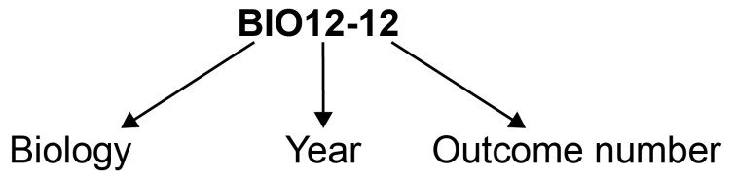

Outcome code | Interpretation
BIO11/12-1 | Biology – outcome number 1
BIO11-8 | Year 11 Biology – outcome number 8
BIO12-12 | Year 12 Biology – outcome number 12

Working Scientifically outcomes 1–7 are common across Year 11 and Year 12.

Knowledge and Understanding outcomes in Year 11 are numbered 8–11.

Knowledge and Understanding outcomes in Year 12 are numbered 12–15.

Coding of Australian Curriculum Content
Australian curriculum content descriptions included in the syllabus are identified by an Australian curriculum code which appears in brackets at the end of each content description. For example:

Conduct investigations, including using ecosystem surveying techniques, safely, competently and methodically for the collection of valid and reliable data (ACSBL003).

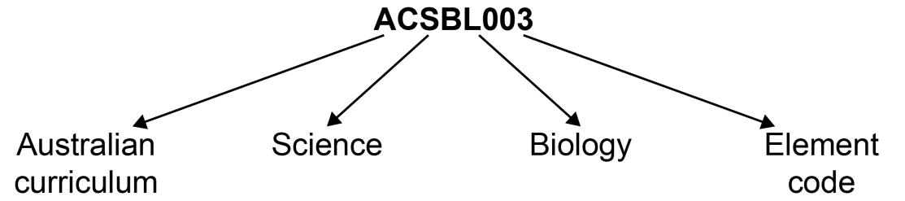

Where a number of content descriptions are jointly represented, all description codes are included, for example (ACSBL001, ACSBL002, ACSBL003).

Learning Across the Curriculum Icons
Learning across the curriculum content, including cross-curriculum priorities, general capabilities and other areas identified as important learning for all students, is incorporated and identified by icons in the syllabus.

Cross-curriculum priorities
Aboriginal and Torres Strait Islander histories and cultures
Asia and Australia’s engagement with Asia
Sustainability

General capabilities
Critical and creative thinking
Ethical understanding
Information and communication technology capability
Intercultural understanding
Literacy
Numeracy
Personal and social capability

Other learning across the curriculum areas
Civics and citizenship
Difference and diversity
Work and enterprise

Rationale
The Biology Stage 6 Syllabus explores the diversity of life from a molecular to a biological systems level. The course examines the interactions between living things and the environments in which they live. It explores the application of biology and its significance in finding solutions to health and sustainability issues in a changing world.
Biology uses Working Scientifically processes to develop scientific investigative skills. It focuses on developing problem-solving and critical thinking skills in order to understand and support the natural environment. When Working Scientifically, students are provided with opportunities to design and conduct biological investigations both individually and collaboratively.
The study of biology, which is often undertaken in interdisciplinary teams, complements the study of other science disciplines and other STEM (Science, Technology, Engineering and Mathematics) related courses. Through the analysis of qualitative and quantitative data, students are encouraged to solve problems and apply knowledge of biological interactions that relate to a variety of fields.
The Biology course builds on the knowledge and skills of the study of living things found in the Science Stage 5 course. The course maintains a practical emphasis in the delivery of the course content and engages with the technologies that assist in investigating current and future biological applications.
The course provides the foundation knowledge and skills required to study biology after completing school, and supports participation in a range of careers in biology and related interdisciplinary industries. It is a fundamental discipline that focuses on personal and public health and sustainability issues, and promotes an appreciation for the diversity of life on the Earth and its habitats.

The Place of the Biology Stage 6 Syllabus in the K–12 Curriculum

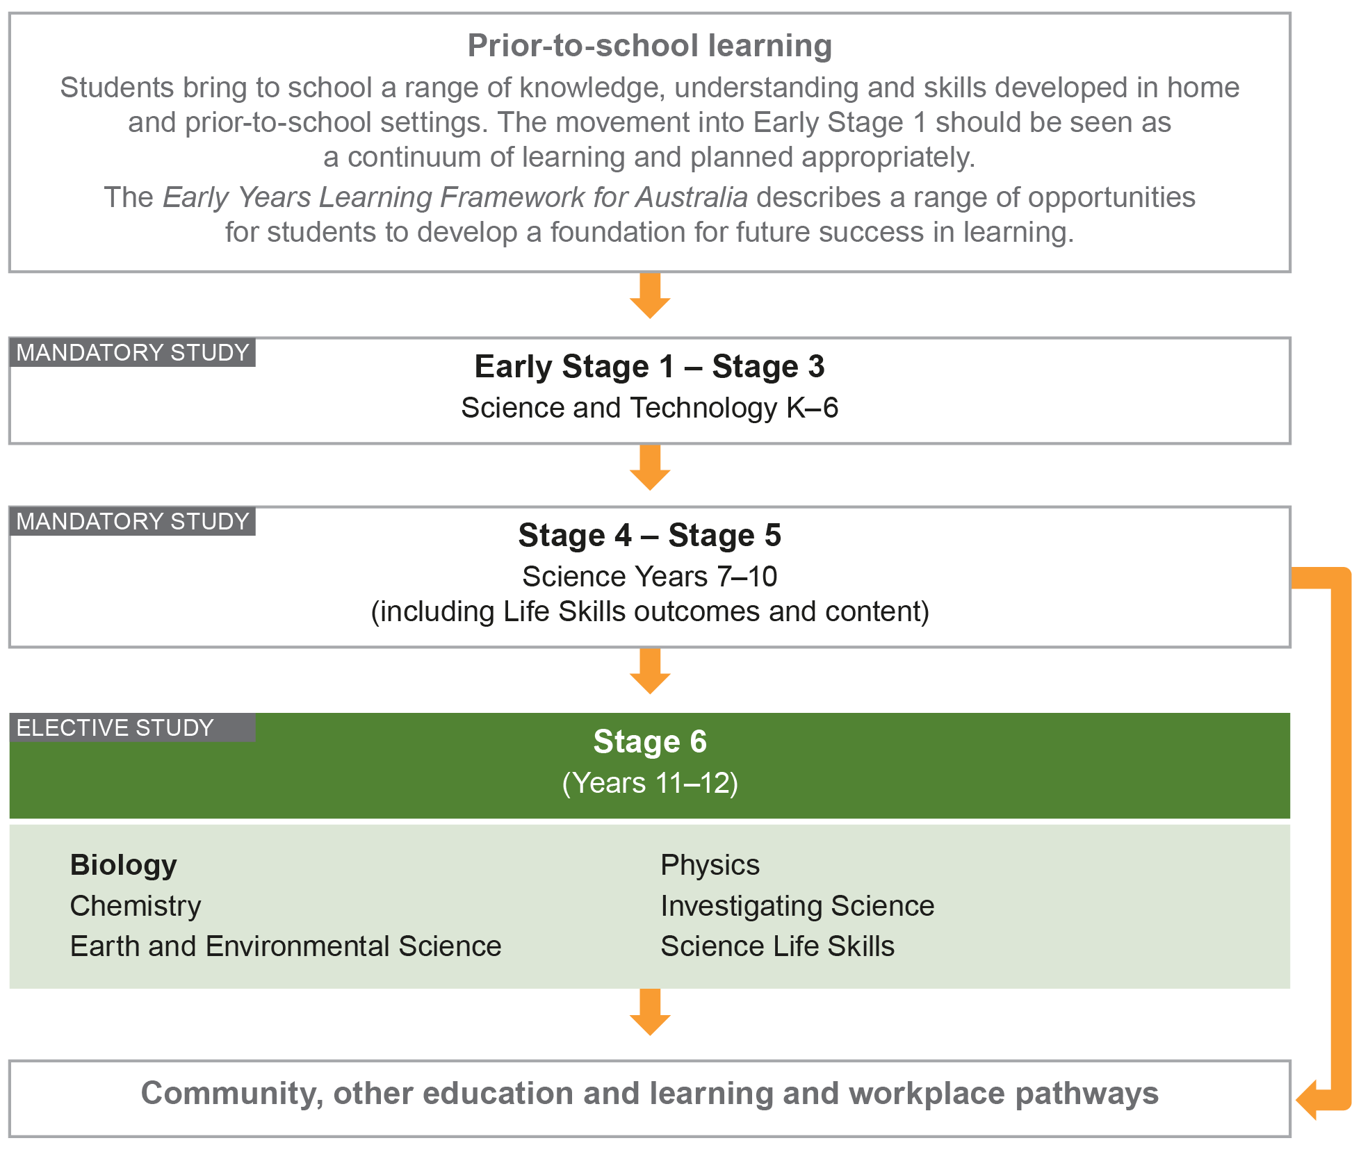

Aim
The study of Biology in Stage 6 enables students to develop an appreciation and understanding of biological concepts that are used to explore the diversity of life, from a molecular to a biological systems level, and the interactions between living things and the environments in which they live. Through applying Working Scientifically skills processes and the use of biological technologies, the course aims to examine how biological practices are developed and used.

Objectives

Skills
Students:
- develop skills in applying the processes of Working Scientifically.

Knowledge and Understanding
Year 11 students:
- develop knowledge and understanding of the structure and function of organisms
- develop knowledge and understanding of the Earth’s biodiversity and the effect of evolution.

Year 12 students:
- develop knowledge and understanding of heredity and genetic technologies
- develop knowledge and understanding of the effects of disease and disorders.

Values and Attitudes
Students:
- develop positive, informed values and attitudes towards biology
- recognise the importance and relevance of biology in their lives
- recognise the influence of economic, political and societal impacts on the development of scientific knowledge
- develop an appreciation of the influence of imagination and creativity in scientific research.

Outcomes

Table of Objectives and Outcomes – Continuum of Learning

Skills
Objective
Students:
- develop skills in applying the processes of Working Scientifically
Stage 6 course outcomes
A student:
Questioning and predicting
BIO11/12-1 develops and evaluates questions and hypotheses for scientific investigation
Planning investigations
BIO11/12-2 designs and evaluates investigations in order to obtain primary and secondary data and information
Conducting investigations
BIO11/12-3 conducts investigations to collect valid and reliable primary and secondary data and information
Processing data and information
BIO11/12-4 selects and processes appropriate qualitative and quantitative data and information using a range of appropriate media
Analysing data and information
BIO11/12-5 analyses and evaluates primary and secondary data and information
Problem solving
BIO11/12-6 solves scientific problems using primary and secondary data, critical thinking skills and scientific processes
Communicating
BIO11/12-7 communicates scientific understanding using suitable language and terminology for a specific audience or purpose

The Working Scientifically outcomes at the beginning of each module are targeted for emphasis. The other Working Scientifically outcomes may also be addressed in each module.

Knowledge and Understanding
Year 11 course | Year 12 course
Objective  Students:  - develop knowledge and understanding of the structure and function of organisms | Objective  Students:  - develop knowledge and understanding of heredity and genetic technologies
Year 11 course outcomes  A student: | Year 12 course outcomes  A student:
BIO11-8 describes single cells as the basis for all life by analysing and explaining cells’ ultrastructure and biochemical processes | BIO12-12 explains the structures of DNA and analyses the mechanisms of inheritance and how processes of reproduction ensure continuity of species
BIO11-9 explains the structure and function of multicellular organisms and describes how the coordinated activities of cells, tissues and organs contribute to macroscopic processes in organisms | BIO12-13 explains natural genetic change and the use of genetic technologies to induce genetic change
Objective  Students:  - develop knowledge and understanding of the Earth’s biodiversity and the effect of evolution | Objective  Students:  - develop knowledge and understanding of the effects of disease and disorders
Year 11 course outcomes  A student: | Year 12 course outcomes  A student:
BIO11-10 describes biological diversity by explaining the relationships between a range of organisms in terms of specialisation for selected habitats and evolution of species | BIO12-14 analyses infectious disease in terms of cause, transmission, management and the organism’s response, including the human immune system
BIO11-11 analyses ecosystem dynamics and the interrelationships of organisms within the ecosystem | BIO12-15 explains non-infectious disease and disorders and a range of technologies and methods used to assist, control, prevent and treat non-infectious disease

Year 11 Course Structure and Requirements
Year 11 course  (120 hours) | Working Scientifically Skills | Modules | Indicative hours | Depth studies
 |  | Module 1  Cells as the Basis of Life | 60 | *15 hours  in Modules 1–4
Module 2
Organisation of Living Things
 |  | Module 3  Biological Diversity | 60
Module 4
Ecosystem Dynamics

*15 hours must be allocated to depth studies within the 120 indicative course hours.

Requirements for Practical Investigations

Scientific investigations include both practical investigations and secondary-sourced investigations. Practical investigations are an essential part of the Year 11 course and must occupy a minimum of 35 hours of course time, including time allocated to practical investigations in depth studies.

Practical investigations include:
- undertaking laboratory experiments, including the use of appropriate digital technologies
- fieldwork.

Secondary-sourced investigations include:
- locating and accessing a wide range of secondary data and/or information
- using and reorganising secondary data and/or information.

One fieldwork exercise must be completed in Year 11.

Year 12 Course Structure and Requirements
Year 12 course  (120 hours) | Working Scientifically Skills | Module | Indicative hours | Depth studies
 |  | Module 5  Heredity | 60 | *15 hours in Modules 5–8
Module 6
Genetic Change
 |  | Module 7  Infectious Disease | 60
Module 8
Non-infectious Disease and Disorders

*15 hours must be allocated to depth studies within the 120 indicative course hours.

Requirements for Practical Investigations

Scientific investigations include both practical investigations and secondary-sourced investigations. Practical investigations are an essential part of the Year 12 course and must occupy a minimum of 35 hours of course time, including time allocated to practical investigations in depth studies.

Practical investigations include:
- undertaking laboratory experiments, including the use of appropriate digital technologies
- fieldwork.

Secondary-sourced investigations include:
- locating and accessing a wide range of secondary data and/or information
- using and reorganising secondary data and/or information.

Assessment and Reporting
Information about assessment in relation to the Biology syllabus is contained in Assessment and Reporting in Biology Stage 6. It outlines course-specific advice and requirements regarding:
- Year 11 and Year 12 school-based assessment requirements
- Year 11 and Year 12 mandatory components and weightings
- External assessment requirements including HSC examination specifications.

This information should be read in conjunction with requirements on the Assessment Certification Examination (ACE) website.

Additional advice is available in the Principles of Assessment for Stage 6.

Content
Content defines what students are expected to know and do as they work towards syllabus outcomes. It provides the foundations for students to successfully progress to the next stage of schooling or post-school opportunities.
Teachers will make decisions about content regarding the sequence, emphasis and any adjustments required based on the needs, interests, abilities and prior learning of students.
Content in Stage 6 syllabuses defines learning expectations that may be assessed in Higher School Certificate examinations.

Organisation of Content
The following diagram provides an illustrative representation of elements of the course and their relationship.

The Year 11 and Year 12 courses each comprise four modules. The skills of Working Scientifically are integrated as course content throughout the syllabus. Each module includes a specific focus on some of the Working Scientifically skills. However, there is scope within each module to engage with all of the Working Scientifically skills.

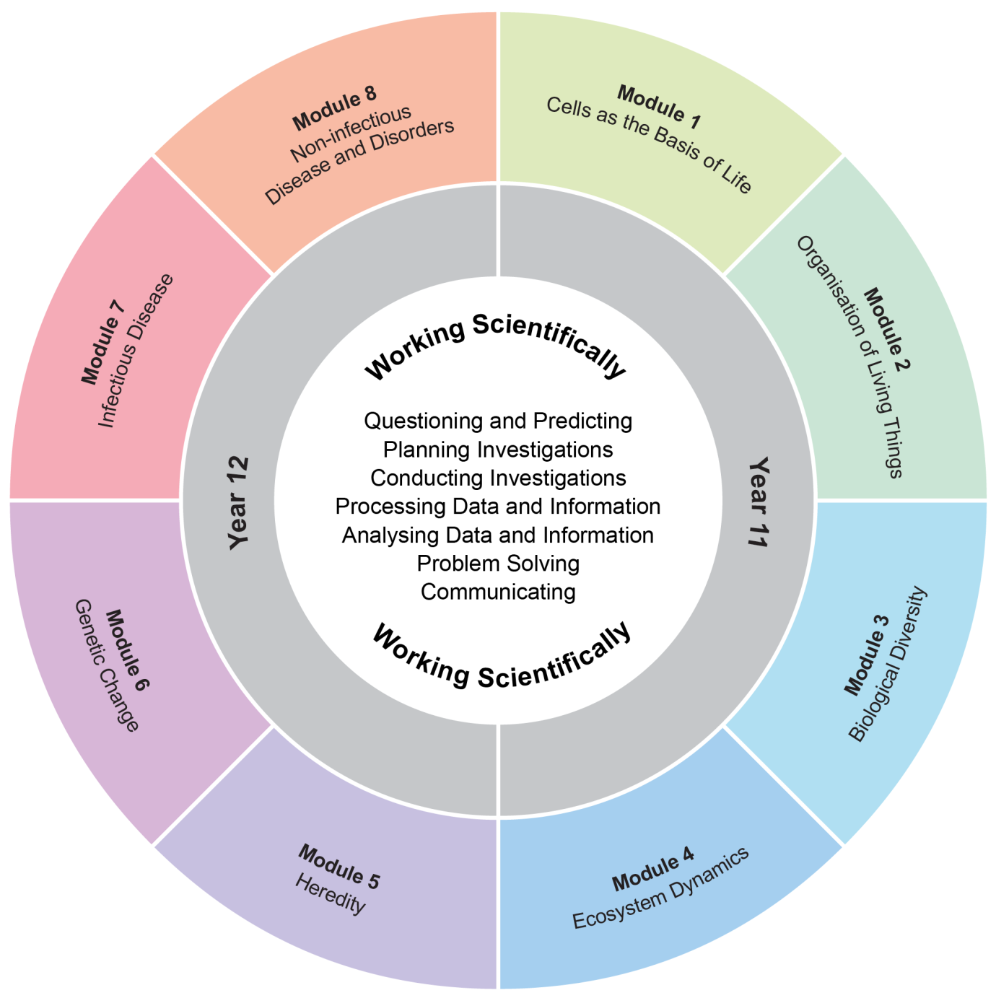

The Working Scientifically outcomes and content are integrated into each module wherever students undertake an investigation.

Working Scientifically
Working Scientifically skills are at the core of conducting practical and secondary-sourced investigations in science.

Opportunities should be provided for students to engage with all the Working Scientifically skills in investigations. In each module, particular outcomes have been identified as those that are most relevant to the intended learning.

Students are challenged to further develop their understanding of Working Scientifically as a group of dynamic and interdependent processes that are applied in each scientific investigation in a way that is appropriate and determined by the activity. This dynamism and interrelatedness adds a level of sophistication to students’ understanding of the true nature and practice of science. Through regular involvement in these processes, applying them as appropriate, in a range of varied practical investigations; students can broaden their interpretation of Working Scientifically beyond the common linear model.

Students are encouraged to select the most appropriate gateway to the Working Scientifically processes. The pathways within the processes become self-evident through the nature of the investigation. An investigation may be instigated by, for example,
- direct observation of a phenomenon
- inconsistencies arising from results of a related investigation
- the qualitative and quantitative analysis of data
- secondary-sourced research.

Students are challenged to be open to:
- refining or redeveloping their chosen procedures
- redefining their questions and/or hypotheses
- modifying their methodologies or designs
- conducting further practical investigations
- conducting further secondary research.

Students are also encouraged to communicate evidence-based conclusions and suggest ideas for future research. Unexpected results are to be welcomed to refine methodologies and to generate further investigation. Knowledge and understanding of science is essential to these processes. Through this practice of science, students can acquire a deeper knowledge and understanding of scientific concepts.

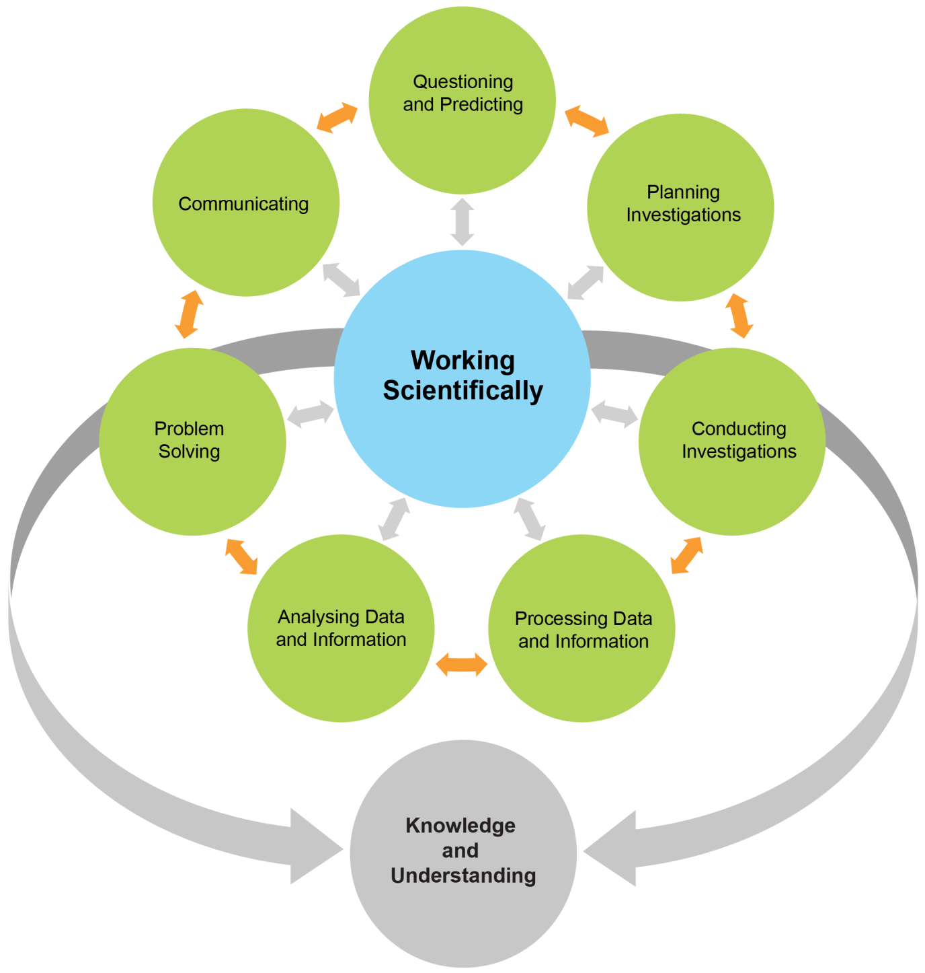
Each of the seven Working Scientifically outcomes represents one of the dynamic and interdependent processes that are central to the study of science and the acquisition of scientific knowledge and skills. This course is structured to provide ongoing opportunities for students to implement these processes, particularly through the depth study provision. The following descriptions of the Working Scientifically outcomes provide further information about the skills students are expected to develop throughout the course.

Questioning and Predicting
Developing, proposing and evaluating inquiry questions and hypotheses challenges students to identify an issue or phenomenon that can be investigated scientifically by gathering primary and/or secondary-sourced data. Students develop inquiry question(s) that require observations, experimentation and/or research to aid in constructing a reasonable and informed hypothesis. The consideration of variables is to be included in the questioning process.

Planning Investigations
Students justify the selection of equipment, resources chosen and design of an investigation. They ensure that all risks are assessed, appropriate materials and technologies are sourced, and all ethical concerns are considered. Variables are to be identified as independent, dependent and controlled to ensure a valid procedure is developed that will allow for the reliable collection of data. Investigations should include strategies that ensure controlled variables are kept constant and an experimental control is used as appropriate.

Conducting Investigations
Students are to select appropriate equipment, employ safe work practices and ensure that risk assessments are conducted and followed. Appropriate technologies are to be used and procedures followed when disposing of waste. The selection and criteria for collecting valid and reliable data is to be methodical and, where appropriate, secondary-sourced information referenced correctly.

Processing Data and Information
Students use the most appropriate and meaningful methods and media to organise and analyse data and information sources, including digital technologies and the use of a variety of visual representations as appropriate. They process data from primary and secondary sources, including both qualitative and quantitative data and information.

Analysing Data and Information
Students identify trends, patterns and relationships; recognise error, uncertainty and limitations in data; and interpret scientific and media texts. They evaluate the relevance, accuracy, validity and reliability of the primary or secondary-sourced data in relation to investigations. They evaluate processes, claims and conclusions by considering the quality of available evidence, and use reasoning to construct scientific arguments. Where appropriate, mathematical models are to be applied, to demonstrate the trends and relationships that occur in data.

Problem Solving
Students use critical thinking skills and creativity to demonstrate an understanding of scientific principles underlying the solutions to inquiry questions and problems posed in investigations. Appropriate and varied strategies are employed, including the use of models, to qualitatively and quantitatively explain and predict cause-and-effect relationships. In Working Scientifically, students synthesise and use evidence to construct and justify conclusions. To solve problems, students: interpret scientific and media texts; evaluate processes, claims and conclusions; and consider the quality of available evidence.

Communicating
Communicating all components of the Working Scientifically processes with clarity and accuracy is essential. Students use qualitative and quantitative information gained from investigations using primary and secondary sources, including digital, visual, written and/or verbal forms of communication as appropriate. They apply appropriate scientific notations and nomenclature. They also appropriately apply and use scientific language that is suitable for specific audiences and contexts.

Investigations
An investigation is a scientific process to answer a question, explore an idea or solve a problem. Investigations include activities such as planning a course of action, collecting data, processing and analysing data, reaching a conclusion and communicating. Investigations may include the collection of primary and/or secondary-sourced data or information.

Practical investigations involve the collection of primary data. They may include:
- undertaking laboratory investigations, including fair tests and controlled experiments
- undertaking fieldwork and surveys
- constructing models.

Secondary-sourced investigations can include:
- researching by using a variety of media
- extracting and reorganising secondary-sourced information in the form of flow charts, tables, graphs, diagrams, prose, keys, spreadsheets and databases
- using models to inform understanding.

Safety
Schools have a legal obligation in relation to safety. Teachers will need to ensure that they comply with relevant legislation as well as system and school requirements in relation to safety when implementing their programs. This includes legislation and guidelines relating to Work Health and Safety, and the handling and storage of chemical and dangerous goods.

Animal Research
Schools have a legal responsibility in relation to the welfare of animals. The keeping of animals and all practical activities involving animals must comply with relevant guidelines or legislation.

Inquiry Questions
Inquiry questions are included in the course content and used to frame the syllabus content within each module. The depth of knowledge and understanding and skill development required to fully address the inquiry questions may vary. This allows for differentiation of the course content to cater for the diversity of learners.

Depth Studies: Year 11 and Year 12

What are Depth Studies?
A depth study is any type of investigation/activity that a student completes individually or collaboratively that allows the further development of one or more concepts found within or inspired by the syllabus. It may be one investigation/activity or a series of investigations/activities.

Depth studies provide opportunities for students to pursue their interests in biology, acquire a depth of understanding, and take responsibility for their own learning. Depth studies promote differentiation and engagement, and support all forms of assessment, including assessment for, as and of learning. Depth studies allow for the demonstration of a range of Working Scientifically skills.

A depth study may be, but is not limited to:
- a practical investigation or series of practical investigations and/or a secondary-sourced investigation or series of secondary-sourced investigations
- presentations, research assignments or fieldwork reports
- the extension of concepts found within the course, either qualitatively and/or quantitatively.

The length of time for any individual study and the pedagogies employed are not prescribed. The time for the depth studies may be allocated to a single study or spread over the year, and incorporate several studies depending on individual school and/or class requirements.

Requirements for Depth Studies
- A minimum of 15 hours of in-class time is allocated in both Year 11 and Year 12.
- At least one depth study must be included in both Year 11 and Year 12.
- The two Working Scientifically outcomes of Questioning and Predicting, and Communicating must be addressed in both Year 11 and Year 12.
- A minimum of two additional Working Scientifically skills outcomes, and further development of at least one Knowledge and Understanding outcome, are to be addressed in all depth studies.

Ideas for Depth Studies

Practical Investigations
- Design and conduct experiments
- Test a claim
- Test a device.

Secondary-sourced Investigations
- Make a documentary or media report
- Conduct a literature review
- Develop an evidence-based argument
- Write a journal article
- Write an essay – historical or theoretical
- Develop an environmental management plan
- Analyse a work of fiction or film for scientific relevance
- Create a visual presentation
- Investigate emerging technologies.

Creating
- Design and invent
- Create a working model
- Create a portfolio.

Fieldwork
Fieldwork may be a starting point for a practical investigation or secondary-sourced study and could be initiated by the following stimuli:
- an excursion
- engagement with community experts.

Data Analysis
Data analysis may be incorporated into a practical investigation or secondary-sourced investigation. For example:
- construction and analysis of graphs/tables
- data analysis from a variety of sources
- research analysis, eg of longitudinal data, resource management data.

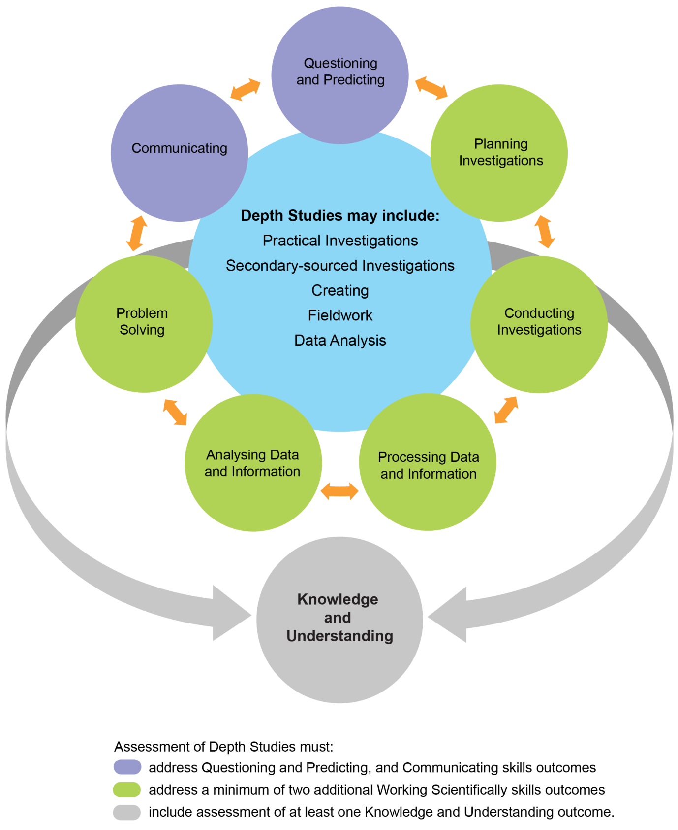

Learning Across the Curriculum
Learning across the curriculum content, including the cross-curriculum priorities and general capabilities, assists students to achieve the broad learning outcomes defined in the NESA Statement of Equity Principles, the Melbourne Declaration on Educational Goals for Young Australians (December 2008) and in the Australian Government’s Core Skills for Work Developmental Framework (2013).

Cross-curriculum priorities enable students to develop understanding about and address the contemporary issues they face.

The cross-curriculum priorities are:
- Aboriginal and Torres Strait Islander histories and cultures
- Asia and Australia’s engagement with Asia
- Sustainability.

General capabilities encompass the knowledge, skills, attitudes and behaviours required to assist students to live and work successfully in the 21st century.

The general capabilities are:
- Critical and creative thinking
- Ethical understanding
- Information and communication technology capability
- Intercultural understanding
- Literacy
- Numeracy
- Personal and social capability.

NESA syllabuses include other areas identified as important learning for all students, including:
- Civics and citizenship
- Difference and diversity
- Work and enterprise.

Learning across the curriculum content is incorporated, and identified by icons, in the content of the Biology Stage 6 Syllabus in the following ways.

Aboriginal and Torres Strait Islander Histories and Cultures
Aboriginal and Torres Strait Islander communities have diverse cultures, social structures and a history of unique, complex knowledge systems. In Biology students are provided with opportunities to learn about how Aboriginal and Torres Strait Islander Peoples have developed and refined knowledge about the world through observation, making predictions, testing (trial and error) and responding to environmental factors within specific contexts. Students investigate examples of Aboriginal and Torres Strait Islander Peoples’ understanding of the environment and the ways in which traditional knowledge and Western scientific knowledge can be complementary.

When planning and programming content relating to Aboriginal and Torres Strait Islander histories and cultures teachers are encouraged to:
- involve local Aboriginal communities and/or appropriate knowledge holders in determining suitable resources, or to use Aboriginal or Torres Strait Islander authored or endorsed publications
- read the Principles and Protocols relating to teaching and learning about Aboriginal and Torres Strait Islander histories and cultures and the involvement of local Aboriginal communities.

Asia and Australia’s Engagement with Asia
Asia and Australia’s engagement with Asia provides rich and engaging contexts for developing students’ scientific and technological knowledge, understanding and skills. In Biology students are provided with opportunities to recognise that the Asia region includes diverse environments. They are provided with opportunities to appreciate how interactions within and between these environments and the impacts of human activity influence the region, including Australia, and have significance for the rest of the world.

Asia plays an important role in scientific and technological research and development in areas such as medicine, natural resource management and natural disaster prediction and management.

Sustainability
Sustainability is concerned with the ongoing capacity of the Earth to maintain all life. It provides authentic contexts for exploring, investigating and understanding systems in natural and human-made environments. In Biology students are provided with opportunities to investigate relationships between systems and system components, and consider the sustainability of food sources and the natural and human environments. They engage in ethical debate and with different perspectives in solving ethical problems.

Critical and Creative Thinking
Critical and creative thinking are integral to activities where students learn to generate and evaluate knowledge, clarify concepts and ideas, seek possibilities, consider alternatives and solve problems. Critical and creative thinking are embedded in the skills and processes of Working Scientifically. In order to make evidence-based decisions, students are provided with opportunities to develop critical and creative thinking skills through: asking and posing questions; making predictions; engaging in practical and secondary-sourced investigations; and analysing and evaluating evidence.

Ethical Understanding
Students are provided with opportunities to develop the capability to assess ethical values and principles, and to understand how reasoning can assist ethical judgement. In Biology students are provided with opportunities to form and make ethical judgements in relation to scientific investigations, design, codes of practice, and the use of scientific information and applications. Students explore the importance of reporting honestly, based on evidence. They apply ethical guidelines in their investigations, particularly in regard to the implications for others and the environment.

Information and Communication Technology Capability
Information and communication technology (ICT) can be used effectively and appropriately to access, create and communicate information and ideas, solve problems and work collaboratively. In Biology students are provided with opportunities to develop ICT capability when they: develop design ideas and solutions; research science concepts and applications; investigate scientific phenomena; and communicate their scientific and technological understandings. In particular, they have opportunities to learn to: access information; collect, analyse and represent data; model and interpret concepts and relationships; and communicate scientific and technological ideas, processes and information.

Intercultural Understanding
Students develop intercultural understanding as they learn to understand themselves in relation to others. This involves students valuing their own cultures and those of others, and engaging with people of diverse cultures in ways that recognise commonalities and differences, create connections and cultivate respect. In Biology students are provided with opportunities to appreciate how diverse cultural perspectives have impacted on the development, breadth and diversity of scientific knowledge and applications. They learn about and engage with issues requiring cultural sensitivity, and learn that scientists work in culturally diverse teams to address issues and solve problems of national and international importance.

Literacy
Literacy is the ability to use a repertoire of knowledge and skills to communicate and comprehend effectively, using a variety of modes and media. Being ‘literate’ is more than the acquisition of technical skills – it includes the ability to identify, understand, interpret, create and communicate effectively using written, visual and digital forms of expression and communication for a number of purposes. In Biology students are provided with opportunities to understand that language varies according to the context and engage with different forms of written and spoken language to communicate scientific concepts. They learn that scientific information can also be presented in the form of diagrams, flow charts, tables, graphs and models.

Numeracy
Numeracy involves recognising and understanding the role of mathematics in the world. Students become numerate as they develop the confidence, willingness and ability to apply mathematics in their lives in constructive and meaningful ways. In Biology students are provided with opportunities to develop numeracy skills through practical measurement and the collection, representation and interpretation of data from first-hand investigations and secondary sources. Students consider issues of uncertainty and reliability in measurement and have opportunities to learn data-analysis skills, identifying trends and patterns from numerical data and graphs. They apply mathematical equations and concepts in order to solve problems.

Personal and Social Capability
Students develop personal and social capability as they learn to understand and manage themselves, their relationships and their lives more effectively. This includes establishing positive relationships, making responsible decisions, working effectively individually and in teams, and constructively handling challenging situations. Through applying the processes of Working Scientifically, students can develop skills in collaboration, peer assessment and review. They plan and conduct a depth study, either individually or in a team.

Civics and Citizenship
Civics and citizenship content involves knowledge and understanding of how our Australian society operates. In Biology students are provided with opportunities to broaden their understanding of aspects of civics and citizenship related to the application of scientific ideas and technological advances, including ecological sustainability and the development of environmental and sustainable practices at a local, regional and national level.

Difference and Diversity
Difference and diversity comprise gender, race and socio-economic circumstances. Students are provided with opportunities to understand and appreciate the difference and diversity they experience in their everyday lives. Working Scientifically provides opportunities for students to work collaboratively, where they can develop an appreciation of the values and ideas of all group members. This appreciation also enables students to identify individual rights, challenge stereotypes and engage with opinions that are different to their own.

Work and Enterprise
Students can develop work-related skills and an appreciation of the value of working individually and collaboratively when conducting investigations. In Biology students are provided with opportunities to prioritise safe practices and understand the potential risks and hazards present when conducting investigations. They engage with risk assessment while working safely in the laboratory or the field.

Biology Year 11 Course Content

Year 11 Course Structure and Requirements
Year 11 course  (120 hours) | Working Scientifically Skills | Modules | Indicative hours | Depth studies
 |  | Module 1  Cells as the Basis of Life | 60 | *15 hours  in Modules 1–4
Module 2
Organisation of Living Things
 |  | Module 3  Biological Diversity | 60
Module 4
Ecosystem Dynamics

*15 hours must be allocated to depth studies within the 120 indicative course hours.

Requirements for Practical Investigations

Scientific investigations include both practical investigations and secondary-sourced investigations. Practical investigations are an essential part of the Year 11 course and must occupy a minimum of 35 hours of course time, including time allocated to practical investigations in depth studies.

Practical investigations include:
- undertaking laboratory experiments, including the use of appropriate digital technologies
- fieldwork.

Secondary-sourced investigations include:
- locating and accessing a wide range of secondary data and/or information
- using and reorganising secondary data and/or information.

One fieldwork exercise must be completed in Year 11.

Working Scientifically Skills
It is expected that the content of each skill will be addressed by the end of the Stage 6 course.

Questioning and Predicting

Outcomes
A student:
- develops and evaluates questions and hypotheses for scientific investigation BIO11/12-1

Content
Students:
- develop and evaluate inquiry questions and hypotheses to identify a concept that can be investigated scientifically, involving primary and secondary data (ACSBL001, ACSBL061, ACSBL096)
- modify questions and hypotheses to reflect new evidence

Planning Investigations

Outcomes
A student:
- designs and evaluates investigations in order to obtain primary and secondary data and information BIO11/12-2

Content
Students:
- assess risks, consider ethical issues and select appropriate materials and technologies when designing and planning an investigation (ACSBL031, ACSBL097)
- justify and evaluate the use of variables and experimental controls to ensure that a valid procedure is developed that allows for the reliable collection of data (ACSBL002)
- evaluate and modify an investigation in response to new evidence

Conducting Investigations

Outcomes
A student:
- conducts investigations to collect valid and reliable primary and secondary data and information BIO11/12-3

Content
Students:
- employ and evaluate safe work practices and manage risks (ACSBL031)
- use appropriate technologies to ensure and evaluate accuracy
- select and extract information from a wide range of reliable secondary sources and acknowledge them using an accepted referencing style

Processing Data and Information

Outcomes
A student:
- selects and processes appropriate qualitative and quantitative data and information using a range of appropriate media BIO11/12-4

Content
Students:
- select qualitative and quantitative data and information and represent them using a range of formats, digital technologies and appropriate media (ACSBL004, ACSBL007, ACSBL064, ACSBL101)
- apply quantitative processes where appropriate
- evaluate and improve the quality of data

Analysing Data and Information

Outcomes
A student:
- analyses and evaluates primary and secondary data and information BIO11/12-5

Content
Students:
- derive trends, patterns and relationships in data and information
- assess error, uncertainty and limitations in data (ACSBL004, ACSBL005, ACSBL033, ACSBL099)
- assess the relevance, accuracy, validity and reliability of primary and secondary data and suggest improvements to investigations (ACSBL005)

Problem Solving

Outcomes
A student:
- solves scientific problems using primary and secondary data, critical thinking skills and scientific processes BIO11/12-6

Content
Students:
- use modelling (including mathematical examples) to explain phenomena, make predictions and solve problems using evidence from primary and secondary sources (ACSBL006, ACSBL010)
- use scientific evidence and critical thinking skills to solve problems

Communicating

Outcomes
A student:
- communicates scientific understanding using suitable language and terminology for a specific audience or purpose BIO11/12-7

Content
Students:
- select and use suitable forms of digital, visual, written and/or oral forms of communication
- select and apply appropriate scientific notations, nomenclature and scientific language to communicate in a variety of contexts (ACSBL008, ACSBL036, ACSBL067, ACSBL102)
- construct evidence-based arguments and engage in peer feedback to evaluate an argument or conclusion (ACSBL034, ACSBL036)

Module 1: Cells as the Basis of Life

Outcomes
A student:
- conducts investigations to collect valid and reliable primary and secondary data and information BIO11/12-3
- selects and processes appropriate qualitative and quantitative data and information using a range of appropriate media BIO11/12-4
- describes single cells as the basis for all life by analysing and explaining cells’ ultrastructure and biochemical processes BIO11-8

Content Focus
Cells are the basis of life. They coordinate activities to form colonial and multicellular organisms. Students examine the structure and function of organisms at both the cellular and tissue levels in order to describe how they facilitate the efficient provision and removal of materials to and from all cells in organisms. They are introduced to and investigate biochemical processes through the application of the Working Scientifically skills processes.

Students are introduced to the study of microbiology and the tools that scientists use in this field.
These tools will be used throughout the course to assist in making predictions and solving problems of a multidisciplinary nature.

Working Scientifically
In this module, students focus on conducting investigations to collect, process and analyse data and identify trends, patterns and relationships related to cell structure and function. Students should be provided with opportunities to engage with all Working Scientifically skills throughout the course.

Content

Cell Structure
Inquiry question: What distinguishes one cell from another?

Students:
- investigate different cellular structures, including but not limited to:
  - examining a variety of prokaryotic and eukaryotic cells (ACSBL032, ACSBL048)
  - describe a range of technologies that are used to determine a cell’s structure and function
- investigate a variety of prokaryotic and eukaryotic cell structures, including but not limited to:
  - drawing scaled diagrams of a variety of cells (ACSBL035)
  - comparing and contrasting different cell organelles and arrangements
  - modelling the structure and function of the fluid mosaic model of the cell membrane (ACSBL045)

Cell Function
Inquiry question: How do cells coordinate activities within their internal environment and the external environment?

Students:
- investigate the way in which materials can move into and out of cells, including but not limited to:
  - conducting a practical investigation modelling diffusion and osmosis (ACSBL046)
  - examining the roles of active transport, endocytosis and exocytosis (ACSBL046)
  - relating the exchange of materials across membranes to the surface-area-to-volume ratio, concentration gradients and characteristics of the materials being exchanged (ACSBL047)
- investigate cell requirements, including but not limited to:
  - suitable forms of energy, including light energy and chemical energy in complex molecules (ACSBL044)
  - matter, including gases, simple nutrients and ions
  - removal of wastes (ACSBL044)
- investigate the biochemical processes of photosynthesis, cell respiration and the removal of cellular products and wastes in eukaryotic cells (ACSBL049, ACSBL050, ACSBL052, ACSBL053)
- conduct a practical investigation to model the action of enzymes in cells (ACSBL050)
- investigate the effects of the environment on enzyme activity through the collection of primary or secondary data (ACSBL050, ACSBL051)

Module 2: Organisation of Living Things

Outcomes
A student:
- selects and processes appropriate qualitative and quantitative data and information using a range of appropriate media BIO11/12-4
- solves scientific problems using primary and secondary data, critical thinking skills and scientific processes BIO11/12-6
- communicates scientific understanding using suitable language and terminology for a specific audience or purpose BIO11/12-7
- explains the structure and function of multicellular organisms and describes how the coordinated activities of cells, tissues and organs contribute to macroscopic processes in organisms BIO11-9

Content Focus
Multicellular organisms typically consist of a number of interdependent transport systems that range in complexity and allow the organism to exchange nutrients, gases and wastes between the internal and external environments. Students examine the relationship between these transport systems and compare nutrient and gas requirements.

Models of transport systems and structures have been developed over time, based on evidence gathered from a variety of disciplines. The interrelatedness of these transport systems is critical in maintaining health and in solving problems related to sustainability in agriculture and ecology.

Working Scientifically
In this module, students focus on collecting, processing and analysing data and information to: identify trends, patterns and relationships; solve problems; and communicate ideas about the organisation of living things. Students should be provided opportunities to engage with all Working Scientifically skills throughout the course.

Content

Organisation of Cells
Inquiry question: How are cells arranged in a multicellular organism?

Students:
- compare the differences between unicellular, colonial and multicellular organisms by:
  - investigating structures at the level of the cell and organelle
  - relating structure of cells and cell specialisation to function
- investigate the structure and function of tissues, organs and systems and relate those functions to cell differentiation and specialisation (ACSBL055)
- justify the hierarchical structural organisation of organelles, cells, tissues, organs, systems and organisms (ACSBL054)

Nutrient and Gas Requirements
Inquiry question: What is the difference in nutrient and gas requirements between autotrophs and heterotrophs?

Students:
- investigate the structure of autotrophs through the examination of a variety of materials, for example: (ACSBL035)
  - dissected plant materials (ACSBL032)
  - microscopic structures
  - using a range of imaging technologies to determine plant structure
- investigate the function of structures in a plant, including but not limited to:
  - tracing the development and movement of the products of photosynthesis (ACSBL059, ACSBL060)
- investigate the gas exchange structures in animals and plants (ACSBL032, ACSBL056) through the collection of primary and secondary data and information, for example:
  - microscopic structures: alveoli in mammals and leaf structure in plants
  - macroscopic structures: respiratory systems in a range of animals
- interpret a range of secondary-sourced information to evaluate processes, claims and conclusions that have led scientists to develop hypotheses, theories and models about the structure and function of plants, including but not limited to: (ACSBL034)
  - photosynthesis
  - transpiration-cohesion-tension theory
- trace the digestion of foods in a mammalian digestive system, including:
  - physical digestion
  - chemical digestion
  - absorption of nutrients, minerals and water
  - elimination of solid waste
- compare the nutrient and gas requirements of autotrophs and heterotrophs

Transport
Inquiry question: How does the composition of the transport medium change as it moves around an organism?

Students:
- investigate transport systems in animals and plants by comparing structures and components using physical and digital models, including but not limited to: (ACSBL032, ACSBL058, ACSBL059, ACSBL060)
  - macroscopic structures in plants and animals
  - microscopic samples of blood, the cardiovascular system and plant vascular systems
- investigate the exchange of gases between the internal and external environments of plants and animals
- compare the structures and function of transport systems in animals and plants, including but not limited to: (ACSBL033)
  - vascular systems in plants and animals
  - open and closed transport systems in animals
- compare the changes in the composition of the transport medium as it moves around an organism

Module 3: Biological Diversity

Outcomes
A student:
- develops and evaluates questions and hypotheses for scientific investigation BIO11/12-1
- designs and evaluates investigations in order to obtain primary and secondary data and information BIO11/12-2
- communicates scientific understanding using suitable language and terminology for a specific audience or purpose BIO11/12-7
- describes biological diversity by explaining the relationships between a range of organisms in terms of specialisation for selected habitats and evolution of species BIO11-10

Content Focus
Biodiversity is important to balance the Earth’s ecosystems. Biodiversity can be affected slowly or quickly over time by natural selective pressures. Human impact can also affect biodiversity over a shorter time period. In this module, students learn about the Theory of Evolution by Natural Selection and the effect of various selective pressures.

Monitoring biodiversity is key to being able to predict future change. Monitoring, including the monitoring of abiotic factors in the environment, enables ecologists to design strategies to reduce the effects of adverse biological change. Students investigate adaptations of organisms that increase the organism’s ability to survive in their environment.

Working Scientifically
In this module, students focus on: designing appropriate investigations; collecting and processing data to develop questions to test hypotheses using appropriate media; communicating their understanding. Students should be provided with opportunities to engage with all Working Scientifically skills throughout the course.

Content

Effects of the Environment on Organisms
Inquiry question: How do environmental pressures promote a change in species diversity and abundance?

Students:
- predict the effects of selection pressures on organisms in ecosystems, including: (ACSBL026, ACSBL090)
  - biotic factors
  - abiotic factors
- investigate changes in a population of organisms due to selection pressures over time, for example: (ACSBL002, ACSBL094)
  - cane toads in Australia
  - prickly pear distribution in Australia

Adaptations
Inquiry question: How do adaptations increase the organism’s ability to survive?

Students:
- conduct practical investigations, individually or in teams, or use secondary sources to examine the adaptations of organisms that increase their ability to survive in their environment, including:
  - structural adaptations
  - physiological adaptations
  - behavioural adaptations
- investigate, through secondary sources, the observations and collection of data that were obtained by Charles Darwin to support the Theory of Evolution by Natural Selection, for example:
  - finches of the Galapagos Islands
  - Australian flora and fauna

Theory of Evolution by Natural Selection
Inquiry question: What is the relationship between evolution and biodiversity?

Students:
- explain biological diversity in terms of the Theory of Evolution by Natural Selection by examining the changes in and diversification of life since it first appeared on the Earth (ACSBL088)
- analyse how an accumulation of microevolutionary changes can drive evolutionary changes and speciation over time, for example: (ACSBL034, ACSBL093)
  - evolution of the horse
  - evolution of the platypus
- explain, using examples, how Darwin and Wallace’s Theory of Evolution by Natural Selection accounts for:
  - convergent evolution
  - divergent evolution
- explain how punctuated equilibrium is different from the gradual process of natural selection

Evolution – the Evidence
Inquiry question: What is the evidence that supports the Theory of Evolution by Natural Selection?

Students:
- investigate, using secondary sources, evidence in support of Darwin and Wallace’s Theory of Evolution by Natural Selection, including but not limited to:
  - biochemical evidence, comparative anatomy, comparative embryology and biogeography (ACSBL089)
  - techniques used to date fossils and the evidence produced
- explain modern-day examples that demonstrate evolutionary change, for example:
  - the cane toad
  - antibiotic-resistant strains of bacteria

Module 4: Ecosystem Dynamics

Outcomes
A student:
- develops and evaluates questions and hypotheses for scientific investigation BIO11/12-1
- designs and evaluates investigations in order to obtain primary and secondary data and information BIO11/12-2
- conducts investigations to collect valid and reliable primary and secondary data and information BIO11/12-3
- selects and processes appropriate qualitative and quantitative data and information using a range of appropriate media BIO11/12-4
- analyses and evaluates primary and secondary data and information BIO11/12-5
- analyses ecosystem dynamics and the interrelationships of organisms within the ecosystem BIO11-11

Content Focus
The Earth’s biodiversity has increased since life first appeared on the planet. The Theory of Evolution by Natural Selection can be used to explain periodic increases and decreases in populations and biodiversity. Scientific knowledge derived from the fossil record, and geological evidence has enabled scientists to offer valid explanations for this progression in terms of biotic and abiotic relationships. Students engage in the study of past ecosystems and create models of possible future ecosystems so that human impact on biodiversity can be minimised. The study of ecosystem dynamics integrates a range of data that can be used to predict environmental change into the future.

Working Scientifically
In this module, students focus on developing questions and hypotheses when planning and conducting investigations. Students study trends, patterns and relationships in data to analyse the interrelationships within and dynamics of an ecosystem. Students should be provided with opportunities to engage with all Working Scientifically skills throughout the course.

Content

Population Dynamics
Inquiry question: What effect can one species have on the other species in a community?

Students:
- investigate and determine relationships between biotic and abiotic factors in an ecosystem, including: (ACSBL019)
  - the impact of abiotic factors (ACSBL021, ACSBL022, ACSBL025)
  - the impact of biotic factors, including predation, competition and symbiotic relationships (ACSBL024)
  - the ecological niches occupied by species (ACSBL023)
  - predicting consequences for populations in ecosystems due to predation, competition, symbiosis and disease (ACSBL019, ACSBL020)
  - measuring populations of organisms using sampling techniques (ACSBL003, ACSBL015)
- explain a recent extinction event (ACSBL024)

Past Ecosystems
Inquiry question: How do selection pressures within an ecosystem influence evolutionary change?

Students:
- analyse palaeontological and geological evidence that can be used to provide evidence for past changes in ecosystems, including but not limited to:
  - Aboriginal rock paintings
  - rock structure and formation
  - ice core drilling
- investigate and analyse past and present technologies that have been used to determine evidence for past changes, for example: (ACSBL005)
  - radiometric dating
  - gas analysis
- analyse evidence that present-day organisms have evolved from organisms in the past by examining and interpreting a range of secondary sources to evaluate processes, claims and conclusions relating to the evolution of organisms in Australia, for example: (ACSBL005, ACSBL027)
  - small mammals
  - sclerophyll plants
- investigate the reasons for changes in past ecosystems, by:
  - interpreting a range of secondary sources to develop an understanding of the changes in biotic and abiotic factors over short and long periods of time (ACSBL025, ACSBL026)
  - evaluating hypotheses that account for identified trends (ACSBL001)

Future Ecosystems
Inquiry question: How can human activity impact on an ecosystem?

Students:
- investigate changes in past ecosystems that may inform our approach to the management of future ecosystems, including:
  - the role of human-induced selection pressures on the extinction of species (ACSBL005, ACSBL028, ACSBL095)
  - models that humans can use to predict future impacts on biodiversity (ACSBL029, ACSBL071)
  - the role of changing climate on ecosystems
- investigate practices used to restore damaged ecosystems, Country or Place, for example:
  - mining sites
  - land degradation from agricultural practices

Biology Year 12 Course Content

Year 12 Course Structure and Requirements
Year 12 course  (120 hours) | Working Scientifically Skills | Module | Indicative hours | Depth studies
 |  | Module 5  Heredity | 60 | *15 hours in Modules 5–8
Module 6
Genetic Change
 |  | Module 7  Infectious Disease | 60
Module 8
Non-infectious Disease and Disorders

*15 hours must be allocated to depth studies within the 120 indicative course hours.

Requirements for Practical Investigations

Scientific investigations include both practical investigations and secondary-sourced investigations. Practical investigations are an essential part of the Year 12 course and must occupy a minimum of 35 hours of course time, including time allocated to practical investigations in depth studies.

Practical investigations include:
- undertaking laboratory experiments, including the use of appropriate digital technologies
- fieldwork.

Secondary-sourced investigations include:
- locating and accessing a wide range of secondary data and/or information
- using and reorganising secondary data and/or information.

Working Scientifically Skills
It is expected that the content of each skill will be addressed by the end of the Stage 6 course.

Questioning and Predicting

Outcomes
A student:
- develops and evaluates questions and hypotheses for scientific investigation BIO11/12-1

Content
Students:
- develop and evaluate inquiry questions and hypotheses to identify a concept that can be investigated scientifically, involving primary and secondary data (ACSBL001, ACSBL061, ACSBL096)
- modify questions and hypotheses to reflect new evidence

Planning Investigations

Outcomes
A student:
- designs and evaluates investigations in order to obtain primary and secondary data and information BIO11/12-2

Content
Students:
- assess risks, consider ethical issues, and select appropriate materials and technologies when designing and planning an investigation (ACSBL031, ACSBL097)
- justify and evaluate the use of variables and experimental controls to ensure that a valid procedure is developed that allows for the reliable collection of data (ACSBL002)
- evaluate and modify an investigation in response to new evidence

Conducting Investigations

Outcomes
A student:
- conducts investigations to collect valid and reliable primary and secondary data and information BIO11/12-3

Content
Students:
- employ and evaluate safe work practices and manage risks (ACSBL031)
- use appropriate technologies to ensure and evaluate accuracy
- select and extract information from a wide range of reliable secondary sources and acknowledge them using an accepted referencing style

Processing Data and Information

Outcomes
A student:
- selects and processes appropriate qualitative and quantitative data and information using a range of appropriate media BIO11/12-4

Content
Students:
- select qualitative and quantitative data and information and represent them using a range of formats, digital technologies and appropriate media (ACSBL004, ACSBL007, ACSBL064, ACSBL101)
- apply quantitative processes where appropriate
- evaluate and improve the quality of data

Analysing Data and Information

Outcomes
A student:
- analyses and evaluates primary and secondary data and information BIO11/12-5

Content
Students:
- derive trends, patterns and relationships in data and information
- assess error, uncertainty and limitations in data (ACSBL004, ACSBL005, ACSBL033, ACSBL099)
- assess the relevance, accuracy, validity and reliability of primary and secondary data and suggest improvements to investigations (ACSBL005)

Problem Solving

Outcomes
A student:
- solves scientific problems using primary and secondary data, critical thinking skills and scientific processes BIO11/12-6

Content
Students:
- use modelling (including mathematical examples) to explain phenomena, make predictions and solve problems using evidence from primary and secondary sources (ACSBL006, ACSBL010)
- use scientific evidence and critical thinking skills to solve problems

Communicating

Outcomes
A student:
- communicates scientific understanding using suitable language and terminology for a specific audience or purpose BIO11/12-7

Content
Students:
- select and use suitable forms of digital, visual, written and/or oral communication
- select and apply appropriate scientific notations, nomenclature and scientific language to communicate in a variety of contexts (ACSBL008, ACSBL036, ACSBL067, ACSBL102)
- construct evidence-based arguments and engage in peer feedback to evaluate an argument or conclusion (ACSBL034, ACSBL036)

Module 5: Heredity

Outcomes
A student:
- selects and processes appropriate qualitative and quantitative data and information using a range of appropriate media BIO11/12-4
- analyses and evaluates primary and secondary data and information BIO11/12-5
- solves scientific problems using primary and secondary data, critical thinking skills and scientific processes BIO11/12-6
- explains the structures of DNA and analyses the mechanisms of inheritance and how processes of reproduction ensure continuity of species BIO12-12

Content Focus
Life continues through the processes of reproduction and heredity. Students expand their knowledge of evolution by understanding the cellular processes involved in increasing genetic diversity. They investigate reproduction and inheritance patterns in both plants and animals as well as the role of DNA in polypeptide synthesis and the uses of technologies in the study of inheritance patterns.

Students also learn about contemporary research and the work of geneticists across a variety of industries, including medical applications and agriculture. They explore the effects on society and the environment through the application of genetic research.

Working Scientifically
In this module, students focus on processing and representing data in appropriate formats to analyse and evaluate trends, relationships and patterns. Students derive and justify valid conclusions about the processes involved in heredity. Students should be provided with opportunities to engage with all Working Scientifically skills throughout the course.

Content

Reproduction
Inquiry question: How does reproduction ensure the continuity of a species?

Students:
- explain the mechanisms of reproduction that ensure the continuity of a species, by analysing sexual and asexual methods of reproduction in a variety of organisms, including but not limited to:
  - animals: advantages of external and internal fertilisation
  - plants: asexual and sexual reproduction
  - fungi: budding, spores
  - bacteria: binary fission (ACSBL075)
  - protists: binary fission, budding
- analyse the features of fertilisation, implantation and hormonal control of pregnancy and birth in mammals (ACSBL075)
- evaluate the impact of scientific knowledge on the manipulation of plant and animal reproduction in agriculture (ACSBL074)

Cell Replication
Inquiry question: How important is it for genetic material to be replicated exactly?

Students:
- model the processes involved in cell replication, including but not limited to:
  - mitosis and meiosis (ACSBL075)
  - DNA replication using the Watson and Crick DNA model, including nucleotide composition, pairing and bonding (ACSBL076, ACSBL077)
- assess the effect of the cell replication processes on the continuity of species (ACSBL084)

DNA and Polypeptide Synthesis
Inquiry question: Why is polypeptide synthesis important?

Students:
- construct appropriate representations to model and compare the forms in which DNA exists in eukaryotes and prokaryotes (ACSBL076)
- model the process of polypeptide synthesis, including: (ACSBL079)
  - transcription and translation
  - assessing the importance of mRNA and tRNA in transcription and translation (ACSBL079)
  - analysing the function and importance of polypeptide synthesis (ACSBL080)
  - assessing how genes and environment affect phenotypic expression (ACSBL081)
- investigate the structure and function of proteins in living things

Genetic Variation
Inquiry question: How can the genetic similarities and differences within and between species be compared?

Students:
- conduct practical investigations to predict variations in the genotype of offspring by modelling meiosis, including the crossing over of homologous chromosomes, fertilisation and mutations (ACSBL084)
- model the formation of new combinations of genotypes produced during meiosis, including but not limited to:
  - interpreting examples of autosomal, sex-linkage, co-dominance, incomplete dominance and multiple alleles (ACSBL085)
  - constructing and interpreting information and data from pedigrees and Punnett squares
- collect, record and present data to represent frequencies of characteristics in a population, in order to identify trends, patterns, relationships and limitations in data, for example:
  - examining frequency data
  - analysing single nucleotide polymorphism (SNP)

Inheritance Patterns in a Population
Inquiry question: Can population genetic patterns be predicted with any accuracy?

Students:
- investigate the use of technologies to determine inheritance patterns in a population using, for example: (ACSBL064, ACSBL085)
- DNA sequencing and profiling (ACSBL086)
- investigate the use of data analysis from a large-scale collaborative project to identify trends, patterns and relationships, for example: (ACSBL064, ACSBL073)
- the use of population genetics data in conservation management
- population genetics studies used to determine the inheritance of a disease or disorder
- population genetics relating to human evolution

Module 6: Genetic Change

Outcomes
A student:
- solves scientific problems using primary and secondary data, critical thinking skills and scientific processes BIO11/12-6
- communicates scientific understanding using suitable language and terminology for a specific audience or purpose BIO11/12-7
- explains natural genetic change and the use of genetic technologies to induce genetic change BIO12-13

Content Focus
Students learn about natural and human-induced causes and effects of genetic change, including mutations, environmental pressure and uses of biotechnology. Students investigate how the processes of inheritance and evolution are applied.

The work of scientists in various fields of work, including agriculture, industry and medicine, can be explored within the context of biotechnology. The impact of biotechnology on biological diversity is also explored in this module.

Working Scientifically
In this module, students focus on analysing trends and patterns and solving problems using evidence from data and information. Students also focus on communicating ideas about genetic change for a specific purpose. Students should be provided with opportunities to engage with all Working Scientifically skills throughout the course.

Content

Mutation
Inquiry question: How does mutation introduce new alleles into a population?

Students:
- explain how a range of mutagens operate, including but not limited to:
  - electromagnetic radiation sources
  - chemicals
  - naturally occurring mutagens
- compare the causes, processes and effects of different types of mutation, including but not limited to:
  - point mutation
  - chromosomal mutation
- distinguish between somatic mutations and germ-line mutations and their effect on an organism (ACSBL082, ACSBL083)
- assess the significance of ‘coding’ and ‘non-coding’ DNA segments in the process of mutation (ACSBL078)
- investigate the causes of genetic variation relating to the processes of fertilisation, meiosis and mutation (ACSBL078)
- evaluate the effect of mutation, gene flow and genetic drift on the gene pool of populations (ACSBL091, ACSBL092)

Biotechnology
Inquiry question: How do genetic techniques affect Earth’s biodiversity?

Students:
- investigate the uses and applications of biotechnology (past, present and future), including: (ACSBL087)
  - analysing the social implications and ethical uses of biotechnology, including plant and animal examples
  - researching future directions of the use of biotechnology
  - evaluating the potential benefits for society of research using genetic technologies
  - evaluating the changes to the Earth’s biodiversity due to genetic techniques

Genetic Technologies
Inquiry question: Does artificial manipulation of DNA have the potential to change populations forever?

Students:
- investigate the uses and advantages of current genetic technologies that induce genetic change
- compare the processes and outcomes of reproductive technologies, including but not limited to:
  - artificial insemination
  - artificial pollination
- investigate and assess the effectiveness of cloning, including but not limited to:
  - whole organism cloning
  - gene cloning
- describe techniques and applications used in recombinant DNA technology, for example:
  - the development of transgenic organisms in agricultural and medical applications (ACSBL087)
- evaluate the benefits of using genetic technologies in agricultural, medical and industrial applications (ACSBL086)
- evaluate the effect on biodiversity of using biotechnology in agriculture
- interpret a range of secondary sources to assess the influence of social, economic and cultural contexts on a range of biotechnologies

Module 7: Infectious Disease

Outcomes
A student:
- develops and evaluates questions and hypotheses for scientific investigation BIO11/12-1
- designs and evaluates investigations in order to obtain primary and secondary data and information BIO11/12-2
- conducts investigations to collect valid and reliable primary and secondary data and information BIO11/12-3
- selects and processes appropriate qualitative and quantitative data and information using a range of appropriate media BIO11/12-4
- analyses infectious disease in terms of cause, transmission, management and the organism’s response, including the human immune system BIO12-14

Content Focus
This module examines the treatment, prevention and control of infectious disease both locally and globally. It includes study of the human immune system and its response to an infectious disease.

The value of studying infectious disease and its causes and effects is highlighted by the cost to humans in terms of losses in productivity and production and the impact on overall health. The module also considers medical and agricultural applications that draw on the work of a variety of scientists.

Working Scientifically
In this module, students focus on developing and evaluating questions and hypotheses when planning and conducting investigations to analyse trends, patterns and relationships in data about infectious diseases. Students should be provided with opportunities to engage with all Working Scientifically skills throughout the course.

Content

Causes of Infectious Disease
Inquiry question: How are diseases transmitted?

Students:
- describe a variety of infectious diseases caused by pathogens, including microorganisms, macroorganisms and non-cellular pathogens, and collect primary and secondary-sourced data and information relating to disease transmission, including: (ACSBL097, ACSBL098, ACSBL116, ACSBL117)
  - classifying different pathogens that cause disease in plants and animals (ACSBL117)
  - investigating the transmission of a disease during an epidemic
  - design and conduct a practical investigation relating to the microbial testing of water or food samples
  - investigate modes of transmission of infectious diseases, including direct contact, indirect contact and vector transmission
- investigate the work of Robert Koch and Louis Pasteur, to explain the causes and transmission of infectious diseases, including:
  - Koch’s postulates
  - Pasteur’s experiments on microbial contamination
- assess the causes and effects of diseases on agricultural production, including but not limited to:
  - plant diseases
  - animal diseases
- compare the adaptations of different pathogens that facilitate their entry into and transmission between hosts (ACSBL118)

Responses to Pathogens
Inquiry question: How does a plant or animal respond to infection?

Students:
- investigate the response of a named Australian plant to a named pathogen through practical and/or secondary-sourced investigation, for example:
  - fungal pathogens
  - viral pathogens
- analyse responses to the presence of pathogens by assessing the physical and chemical changes that occur in the host animals cells and tissues (ACSBL119, ACSBL120, ACSBL121, ACSBL122)

Immunity
Inquiry question: How does the human immune system respond to exposure to a pathogen?

Students:
- investigate and model the innate and adaptive immune systems in the human body (ACSBL119)
- explain how the immune system responds after primary exposure to a pathogen, including innate and acquired immunity

Prevention, Treatment and Control
Inquiry question: How can the spread of infectious diseases be controlled?

Students:
- investigate and analyse the wide range of interrelated factors involved in limiting local, regional and global spread of a named infectious disease
- investigate procedures that can be employed to prevent the spread of disease, including but not limited to: (ACSBL124)
  - hygiene practices
  - quarantine
  - vaccination, including passive and active immunity (ACSBL100, ACSBL123)
  - public health campaigns
  - use of pesticides
  - genetic engineering
- investigate and assess the effectiveness of pharmaceuticals as treatment strategies for the control of infectious disease, for example:
  - antivirals
  - antibiotics
- investigate and evaluate environmental management and quarantine methods used to control an epidemic or pandemic
- interpret data relating to the incidence and prevalence of infectious disease in populations, for example:
  - mobility of individuals and the portion that are immune or immunised (ACSBL124, ACSBL125)
  - Malaria or Dengue Fever in South East Asia
- evaluate historical, culturally diverse and current strategies to predict and control the spread of disease (ACSBL125)
- investigate the contemporary application of Aboriginal protocols in the development of particular medicines and biological materials in Australia and how recognition and protection of Indigenous cultural and intellectual property is important, for example:
  - bush medicine
  - smoke bush in Western Australia

Module 8: Non-infectious Disease and Disorders

Outcomes
A student:
- analyses and evaluates primary and secondary data and information BIO11/12-5
- solves scientific problems using primary and secondary data, critical thinking skills and scientific processes BIO11/12-6
- communicates scientific understanding using suitable language and terminology for a specific audience or purpose BIO11/12-7
- explains non-infectious disease and disorders and a range of technologies and methods used to assist, control, prevent and treat non-infectious disease BIO12-15

Content Focus
Students engage with the study of non-infectious disease and disorders, including their causes and effects on human health. They explore technologies and their uses in treating disease and disorders as well as the epidemiology of non-infectious disease in populations.

This module examines the practical applications of STEM. It looks at the importance of understanding the multidisciplinary nature of science applications. It also examines physiology and engineered solutions to problems related to the management of human disorders.

Working Scientifically
In this module, students focus on collecting and processing data to analyse trends and patterns and solve problems. They also focus on communicating ideas about non-infectious disease and disorders. Students should be provided with opportunities to engage with all Working Scientifically skills throughout the course.

Content

Homeostasis
Inquiry question: How is an organism’s internal environment maintained in response to a changing external environment?

Students:
- construct and interpret negative feedback loops that show homeostasis by using a range of sources, including but not limited to: (ACSBL101, ACSBL110, ACSBL111)
  - temperature (ACSBL098)
  - glucose
- investigate the various mechanisms used by organisms to maintain their internal environment within tolerance limits, including:
  - trends and patterns in behavioural, structural and physiological adaptations in endotherms that assist in maintaining homeostasis (ACSBL099, ACSBL114)
  - internal coordination systems that allow homeostasis to be maintained, including hormones and neural pathways (ACSBL112, ACSBL113, ACSBL114)
  - mechanisms in plants that allow water balance to be maintained (ACSBL115)

Causes and Effects
Inquiry question: Do non-infectious diseases cause more deaths than infectious diseases?

Students:
- investigate the causes and effects of non-infectious diseases in humans, including but not limited to:
  - genetic diseases
  - diseases caused by environmental exposure
  - nutritional diseases
  - cancer
- collect and represent data to show the incidence, prevalence and mortality rates of non-infectious diseases, for example:
  - nutritional diseases
  - diseases caused by environmental exposure

Epidemiology
Inquiry question: Why are epidemiological studies used?

Students:
- analyse patterns of non-infectious diseases in populations, including their incidence and prevalence, including but not limited to:
  - nutritional diseases
  - diseases caused by environmental exposure
- investigate the treatment/management, and possible future directions for further research, of a non-infectious disease using an example from one of the non-infectious diseases categories listed above
- evaluate the method used in an example of an epidemiological study
- evaluate, using examples, the benefits of engaging in an epidemiological study

Prevention
Inquiry question: How can non-infectious diseases be prevented?

Students:
- use secondary sources to evaluate the effectiveness of current disease-prevention methods and develop strategies for the prevention of a non-infectious disease, including but not limited to:
  - educational programs and campaigns
  - genetic engineering

Technologies and Disorders
Inquiry question: How can technologies be used to assist people who experience disorders?

Students:
- explain a range of causes of disorders by investigating the structures and functions of the relevant organs, for example:
  - hearing loss
  - visual disorders
  - loss of kidney function
- investigate technologies that are used to assist with the effects of a disorder, including but not limited to: (ACSBL100)
  - hearing loss: cochlear implants, bone conduction implants, hearing aids
  - visual disorders: spectacles, laser surgery
  - loss of kidney function: dialysis
- evaluate the effectiveness of a technology that is used to manage and assist with the effects of a disorder (ACSBL100)

Glossary
Glossary term | Definition
abiotic | The non-living components of the environment.
Aboriginal and Torres Strait Islander Peoples | Aboriginal Peoples are the first peoples of Australia and are represented by over 250 language groups each associated with a particular Country or territory. Torres Strait Islander Peoples whose island territories to the north east of Australia were annexed by Queensland in 1879 are also Indigenous Australians and are represented by five cultural groups.  An Aboriginal and/or Torres Strait Islander person is someone who:  - is of Aboriginal and/or Torres Strait Islander descent  - identifies as an Aboriginal person and/or Torres Strait Islander person, and  - is accepted as such by the Aboriginal and/or Torres Strait Islander community in which they live.
allele | A variant form of a gene.
biota (biotic) | All the living organisms in a specific region or area, including animals, plants and microorganisms.
conclusion | A judgement based on evidence.
controlled variable | A variable that is kept constant (or changed in constant ways) during an investigation.
Country | An area that is traditionally owned and looked after by an Aboriginal language group or community, or by certain people within that group. The term may indicate more than simply a geographical area − it is also a concept that can encompass the spiritual meanings and feelings of attachment associated with that area.
dependent variable | A variable that changes in response to changes to the independent variable in an investigation.
digital technologies | Systems that handle digital data, including hardware and software, for specific purposes.
environment | All surroundings, both living and non-living.
gene pool | The stock of different genes in an interbreeding population.
hypothesis | A tentative explanation for an observed phenomenon, expressed as a precise and unambiguous statement that can be supported or refuted by investigation.
independent variable | A variable that is changed in an investigation to see what effect it has on the dependent variable.
Indigenous cultural and intellectual property | Includes objects, sites, cultural knowledge, cultural expression and the arts, that have been transmitted or continue to be transmitted through generations as belonging to a particular Indigenous group or Indigenous people as a whole or their territory.
investigation | A scientific process of answering a question, exploring an idea or solving a problem, which requires activities such as planning a course of action, collecting data, interpreting data, reaching a conclusion and communicating these activities. Investigations can include practical and/or secondary-sourced data or information.
microevolution | A change in gene frequency in a population over a short period of time.
model | A representation that describes, simplifies, clarifies or provides an explanation of the workings, structure or relationships within an object, system or idea.
niche | A position or function in a habitat that provides all the requirements for life of a species.
Place | A space mapped out by physical or intangible boundaries that individuals or groups of Torres Strait Islander Peoples occupy and regard as their own. Places are spaces that have varying degrees of spirituality.
plan | Decide on a course of action, and make arrangements relating to that course of action, in advance.
practical investigation | An investigation that involves systematic scientific inquiry by planning a course of action and using equipment to collect data and/or information. Practical investigations include a range of hands-on activities, and can include laboratory investigations and fieldwork.
primary sources/ primary data | Information created by a person or persons directly involved in a study or observing an event.
protocol | Appropriate ways of behaving, communicating and showing respect for the diversity of histories and cultures. This involves appreciation of the knowledge, standing and status of people within a local Aboriginal community. Protocols inevitably vary between communities, and between people within a community. In establishing partnerships between Aboriginal communities and industries or professions, it is especially important that protocols are acknowledged and respected.
reliability | An extent to which repeated observations and/or measurements taken under identical circumstances will yield similar results.
secondary-sourced investigation | An investigation that involves systematic scientific inquiry by planning a course of action and sourcing data and/or information from other people, including written information, reports, graphs, tables, diagrams and images.
symbiosis | Interaction between two different organisms living in close physical association, including mutualism, commensalism, and parasitism. Symbiosis can be positive (beneficial) or negative.
technology | All types of human-made systems, tools, machines and processes that can help solve human problems or satisfy needs or wants, including modern computational and communication devices.
theory | A set of concepts, claims and/or laws that can be used to explain and predict a wide range of related observed phenomena. Theories are typically founded on clearly identified assumptions, are testable, produce reproducible results and have explanatory power.
translation | The process by which a sequence of nucleotide triplets in a messenger RNA molecule gives rise to a specific sequence of amino acids during synthesis of a polypeptide or protein.
validity | An extent to which tests measure what was intended; an extent to which data, inferences and actions produced from tests and other processes are accurate.
variable | In an investigation, a factor that can be changed, maintained or measured − eg time, distance, light, temperature.
vector | An insect or animal that carries a disease from one animal or plant to another.

